10-1 & 11.3 Opener - Circles, Circumference, Area, and Sectors
Name: _________________________________ Date:________ Period:________
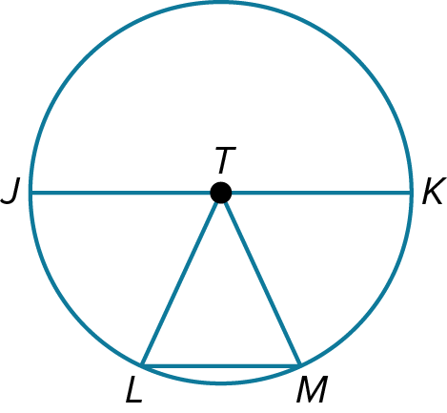
- Refer to the circle at the right.
- Name the circle.

- Name the radii of the circle.

- Name the chords of the circle.

- Find the area of the sector and circle.
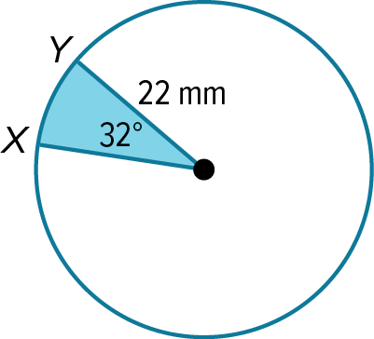
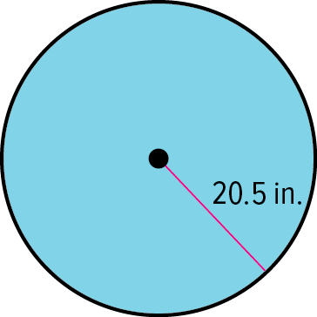

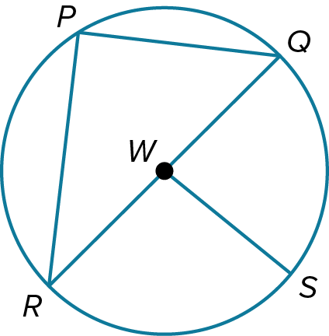

- Refer to ⨀W.
- Suppose the radius of the circle is 37 yards. Find the diameter.

- If RQ = 14 meters, find SW.

10-1 & 11.3 Exit Slip - Circles, Circumference, Area, and Sectors
Name: _________________________________ Date:________ Period:________
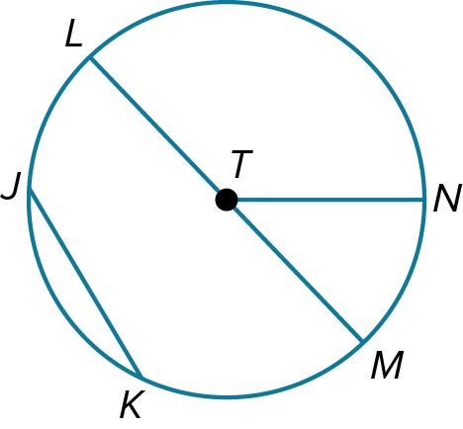
- Refer to the circle at the right.
- Name the circle.

- Name the radii of the circle.

- Name the chords of the circle.

- Find the area of the sector and circle.
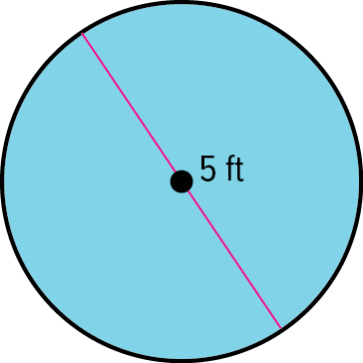
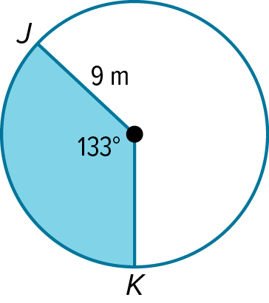

- Refer to ⨀W.
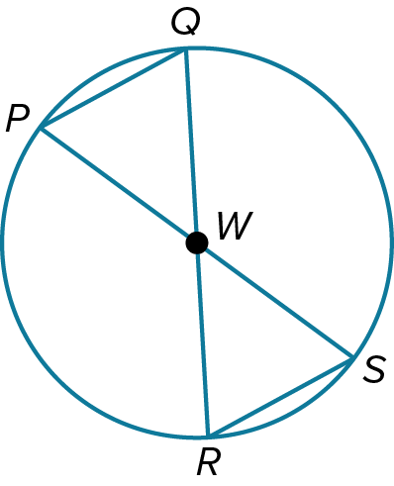
- If PS = 8 meters, find SW. .

- If WP = 12 inches, find QW and QR.

10.2 Opener – Angles and Arcs
Name: _________________________________ Date:________ Period:________
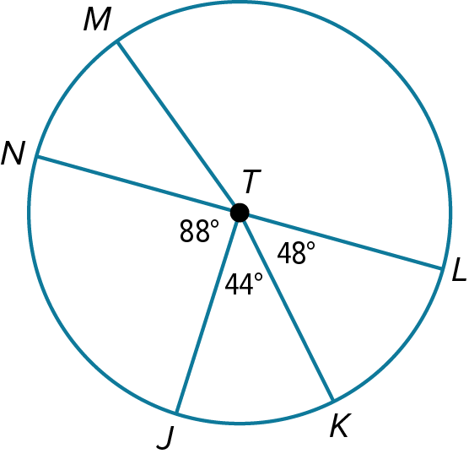
- NL and MK are diameters of ⨀T. Identify each arc as a major arc, minor arc, or semicircle. Then find each measure.

$$m\overset{⏜}{JL}$$
$$INCLUDEPICTURE "https://lh7-us.googleusercontent.com/docsz/AD_4nXfKW486HcnO-hvZvqtO8QxtS0S0UawC1qU2BS4y4eVSjj3ThO2pJcTMHtCiFj_RWCLaKyA4g325La21wrMFa6tb_TDjoj7DCXy0hi8aW--iZCa0qLP4XtwuBoso3c0HxOvZoGfAm4I9Z7HawiB-WDDdz8tvfNvr_swoAMoJ4n0s_tJNFOfFMg?key=JBM283DQA1HiGE8lJqcasg" \backslash * MERGEFORMATINET INCLUDEPICTURE "https://lh7-us.googleusercontent.com/docsz/AD_4nXeZyCbRF_tDZIWdaFvkE3j_5ECS1o3tH2X2IuahHlN_cf8rBWm2qExnEqHLnIdskcrsdmaK_y5CcXdp8vXwgF2Ionz_iGVRdbWXNVbGs0AJAknS3c76jKJgZX6nUzNIfezENfoDPtoyuJFvAdThMA6EDqxNYKwIdZd-I319TFJ6VYwQ2H-Rxw?key=SlWCBpM0QA0XSU5cd9Vd2g" \backslash * MERGEFORMATINET$$
$m\overset{⏜}{LKM }$

$m\overset{⏜}{NL}$

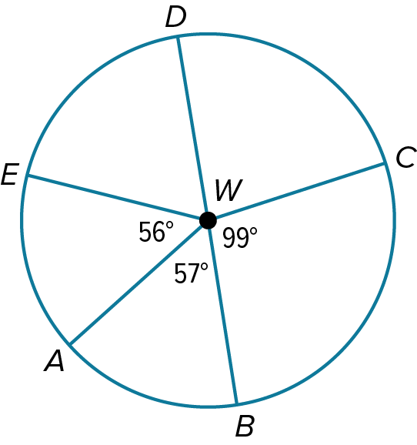
- Use ⨀W to find the length of each arc to the nearest hundredth. DB is a diameter.
$\overset{⏜}{CB}$ if the diameter is 23 millimeters.

- Convert from radians to degrees, and then degrees to radians.
60° $\frac{2π}{3}$ radians

10.2 Exit Slip – Angles and Arcs
Name: _________________________________ Date:________ Period:________
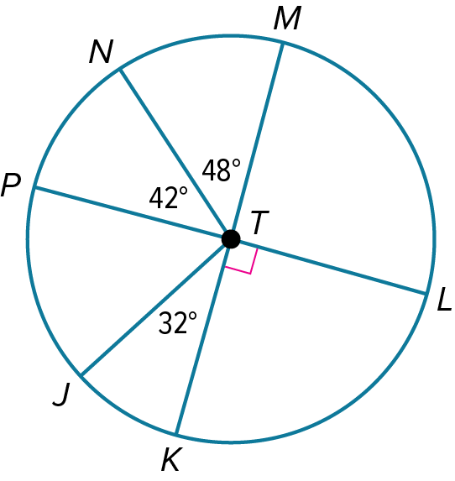
- PL and KM are diameters of ⨀T. Identify each arc as a major arc, minor arc, or semicircle. Then find each measure.

$$m\overset{⏜}{JKL}$$
$$INCLUDEPICTURE "https://lh7-us.googleusercontent.com/docsz/AD_4nXfKW486HcnO-hvZvqtO8QxtS0S0UawC1qU2BS4y4eVSjj3ThO2pJcTMHtCiFj_RWCLaKyA4g325La21wrMFa6tb_TDjoj7DCXy0hi8aW--iZCa0qLP4XtwuBoso3c0HxOvZoGfAm4I9Z7HawiB-WDDdz8tvfNvr_swoAMoJ4n0s_tJNFOfFMg?key=JBM283DQA1HiGE8lJqcasg" \backslash * MERGEFORMATINET INCLUDEPICTURE "https://lh7-us.googleusercontent.com/docsz/AD_4nXeZyCbRF_tDZIWdaFvkE3j_5ECS1o3tH2X2IuahHlN_cf8rBWm2qExnEqHLnIdskcrsdmaK_y5CcXdp8vXwgF2Ionz_iGVRdbWXNVbGs0AJAknS3c76jKJgZX6nUzNIfezENfoDPtoyuJFvAdThMA6EDqxNYKwIdZd-I319TFJ6VYwQ2H-Rxw?key=SlWCBpM0QA0XSU5cd9Vd2g" \backslash * MERGEFORMATINET$$
$m\overset{⏜}{PJ }$

$m\overset{⏜}{ML}$

- Use ⨀W to find the length of each arc to the nearest hundredth. DB is a diameter.
$\overset{⏜}{DCB}$ if the radius is 104 feet.

- Convert from radians to degrees, and then degrees to radians.
270° $π$radians

10-3 Opener – Arcs and Chords
Name: _________________________________ Date:________ Period:________
- Find the value of x.
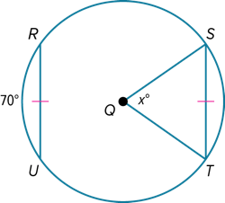
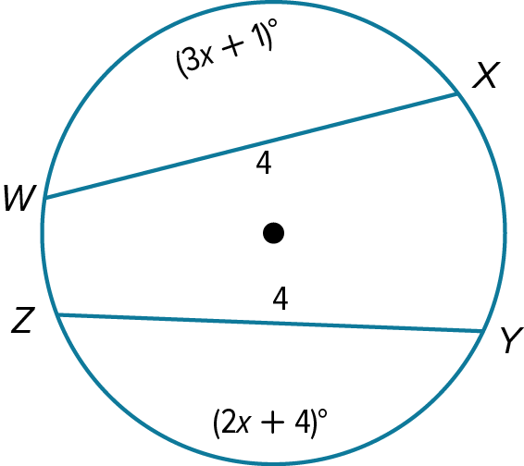

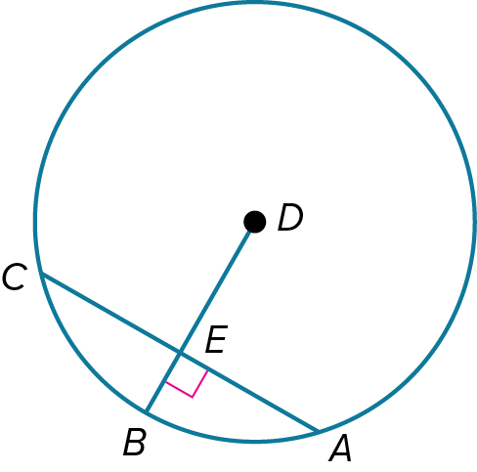
- In ⨀D, DB = 5 and CA = 8. Find each measure.
DE

EB

AE

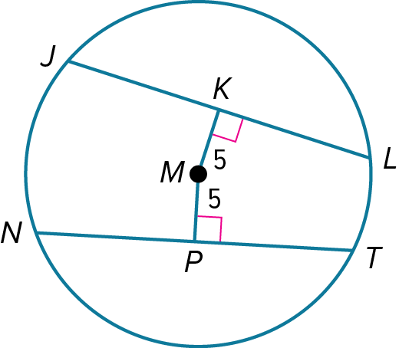
- In ⨀M, JL = 23 and NT = 3x – 1. What is the value of x?

10-3 Exit Slip – Arcs and Chords
Name: _________________________________ Date:________ Period:________
- Find the value of x.
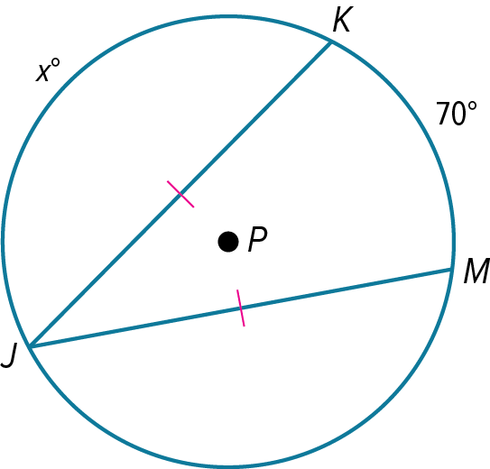
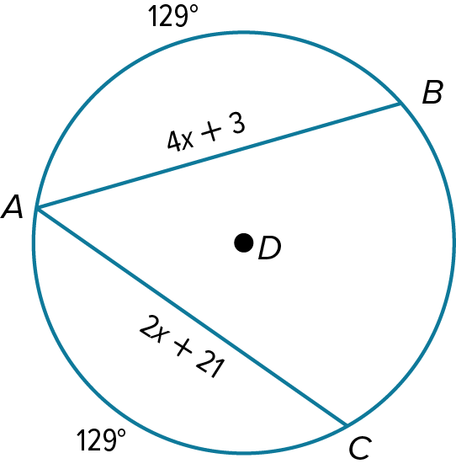

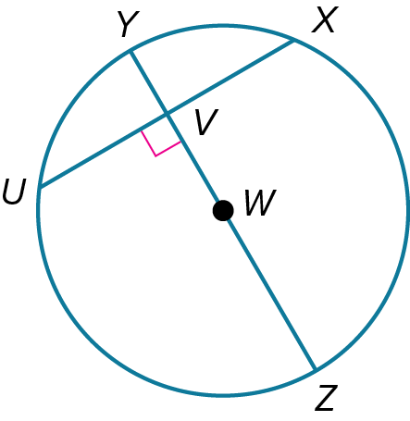
- In ⨀W, YZ = 17, UX = 11, and $m\overset{⏜}{UX}=80.6°.$ Find each measure. Round to the nearest hundredth, if necessary.
VY

$m\overset{⏜}{UY}$

UV
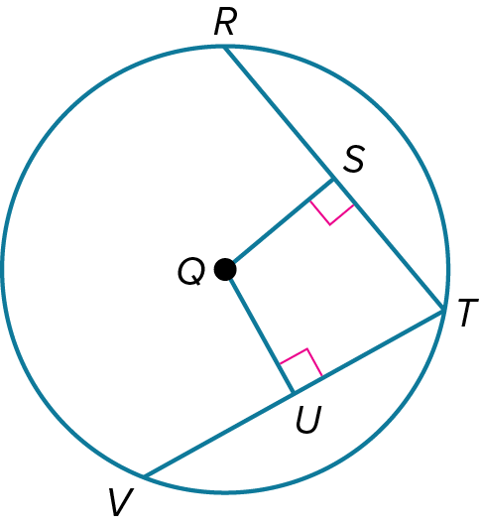
- In ⨀Q, $\overline{RT} ≅ \overline{VT}$, SQ = 3x – 2, and UQ = 2x – 1. What is the value of x?

10-4 Opener – Inscribed Angles
Name: _________________________________ Date:________ Period:________
- Find each measure.
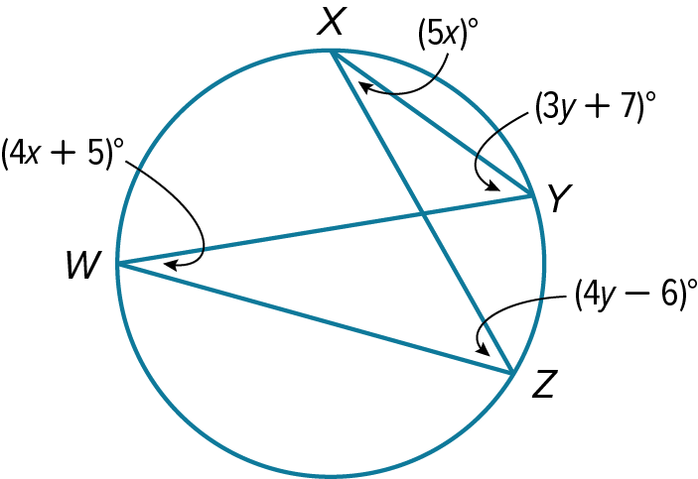
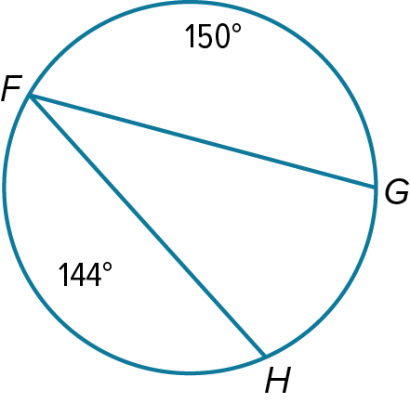
$m∠F$ $m∠W$

$m∠Y$

- Prove the following.
Given: ⊙C; $\overline{XZ}$ and $\overline{WY}$ are diameters.
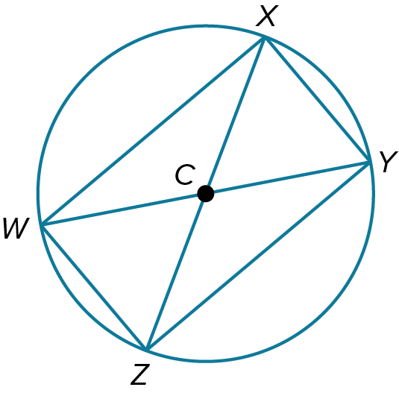
Prove: $∆XZW\sim ∆YWZ$

10-4 Exit Slip – Inscribed Angles
Name: _________________________________ Date:________ Period:________
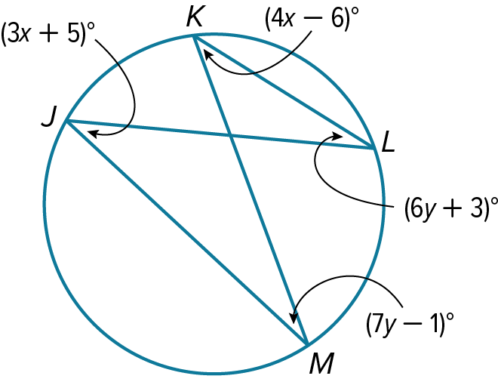
- Find each measure.
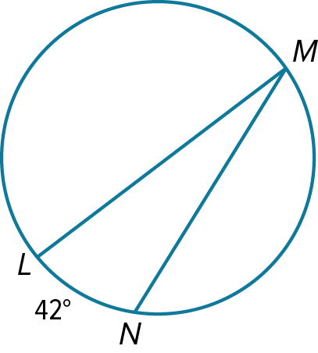
$m∠M$ $m∠J$

$m∠M$

- Prove the following.
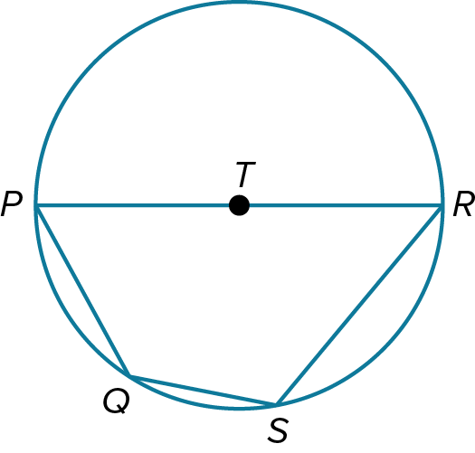
Given: ⊙T, $\overline{PR}$ is a diameter
Prove: ∠S and ∠P are supplementary

10-5 & 10-6 Opener – Tangents, Secants, and Angle Measures
Name: _________________________________ Date:________ Period:________
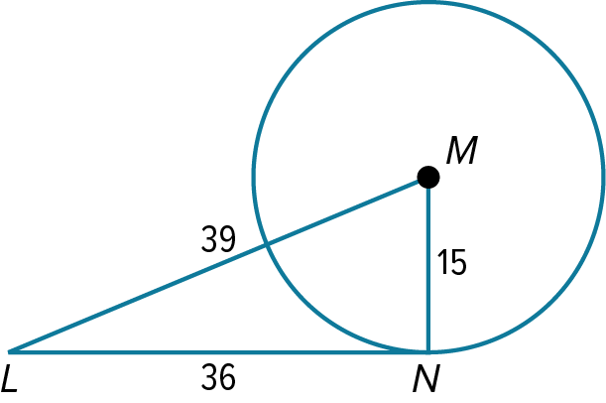
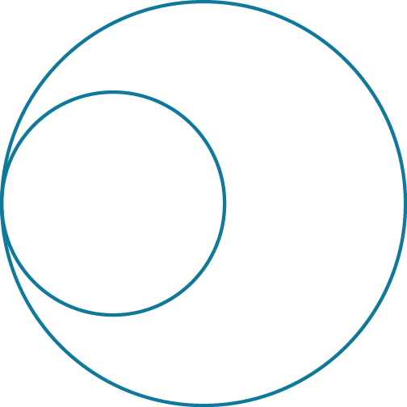
- Identify the number of common tangents that exist between each pair of circles. If no common tangent exists, state no common tangent. Determine if the given segment is tangent to the circle.
$\overline{LN}$

- Find the value of x. Assume that segments that appear to be tangent are tangent.
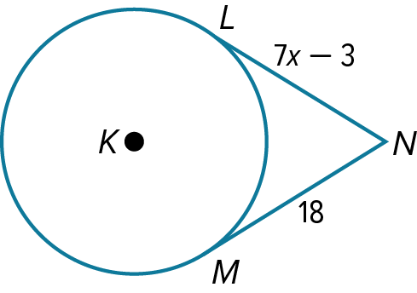

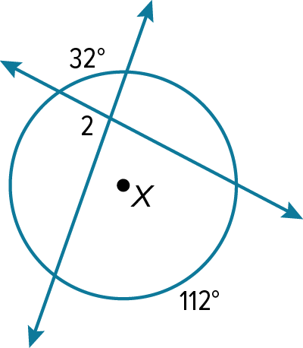
- Find the measure.
$m∠2$

10-5 & 10-6 Exit Slip – Tangents, Secants, and Angle Measures
Name: _________________________________ Date:________ Period:________
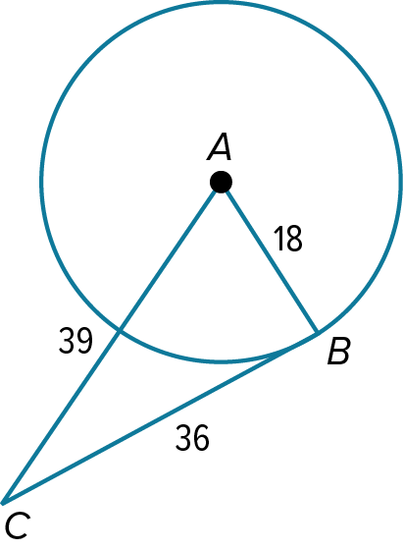
- Identify the number of common tangents that exist between each pair of circles. If no common tangent exists, state no common tangent. Determine if the given segment is tangent to the circle.

$\overline{BC}$

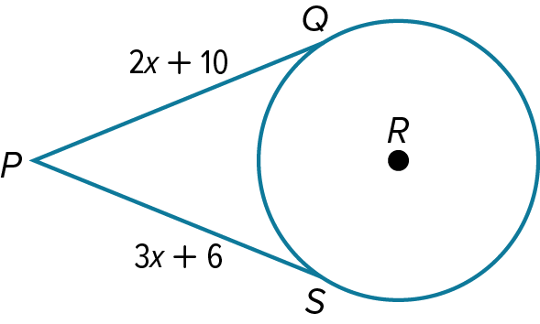
- Find the value of x. Assume that segments that appear to be tangent are tangent.

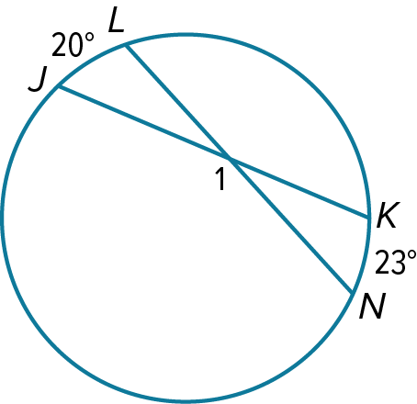
- Find the measure.
$m∠1$

10-7 Opener – Equation of a Circle
Name: _________________________________ Date:________ Period:________
- Write the equation of each circle.
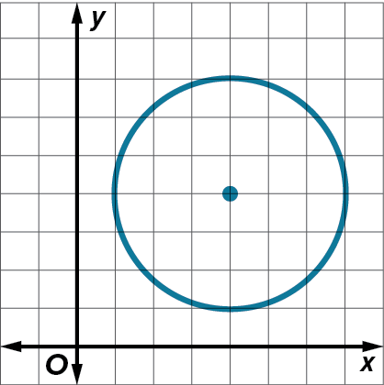
center at (–4, 8), diameter 14 center at (4, –6), passes through (7, –3)

- State the coordinates of the center and the measure of the radius of the circle with the given equation.
$x^{2} + y^{2} + 6x + 4y – 3 = 0$ $x^{2}+ y^{2} = 9$

10-7 Exit Slip – Equation of a Circle
Name: _________________________________ Date:________ Period:________
- Write the equation of each circle.
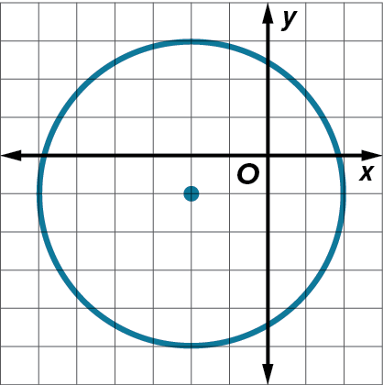
center at (0, 0), radius 12 center at (–9, 6), passes through (–5, 2)

- State the coordinates of the center and the measure of the radius of the circle with the given equation.
$x^{2} + y^{2} – 1 = 0$ ${(x-2)}^{2}+({y+3)}^{2} = 4$

