6-1 Opener - Perpendicular Bisectors
Name: _________________________________ Date:________ Period:________
Find each measure.

Find AB. Find JK.
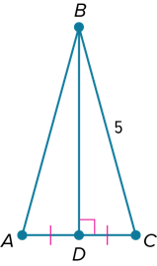
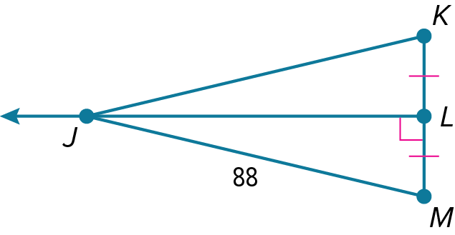

- Find AD if F is the circumcenter of ∆AEC, DF = 6.1, and EF = 13.2. Round to the nearest tenth.
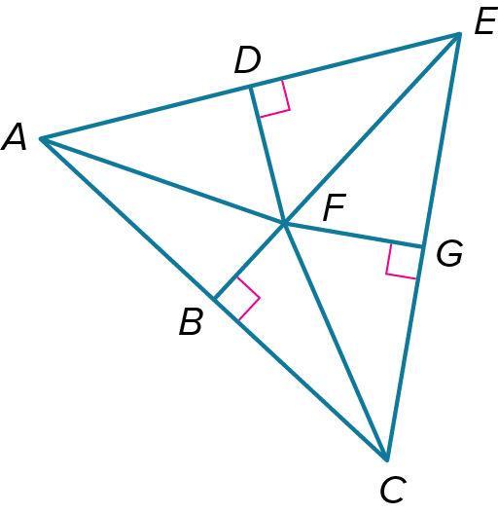

6-1 Exit Slip - Perpendicular Bisectors
Name: _________________________________ Date:________ Period:________
Find each measure.

Find NM. Find QT.
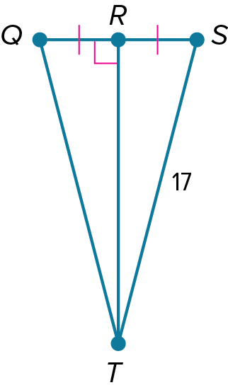
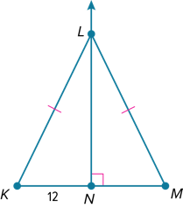

- Find AB if F is the circumcenter of ∆AEC, BF = 5.2, and FC = 12.7. Round to the nearest tenth.

6-2 Opener – Angle Bisectors
Name: _________________________________ Date:________ Period:________
- Find each measure.
find $m∠TWU$ find $m∠GDH$

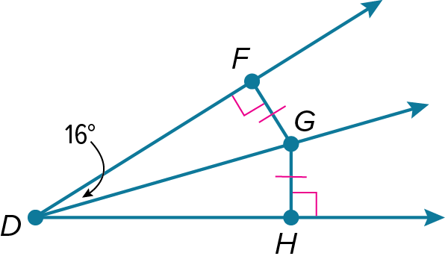
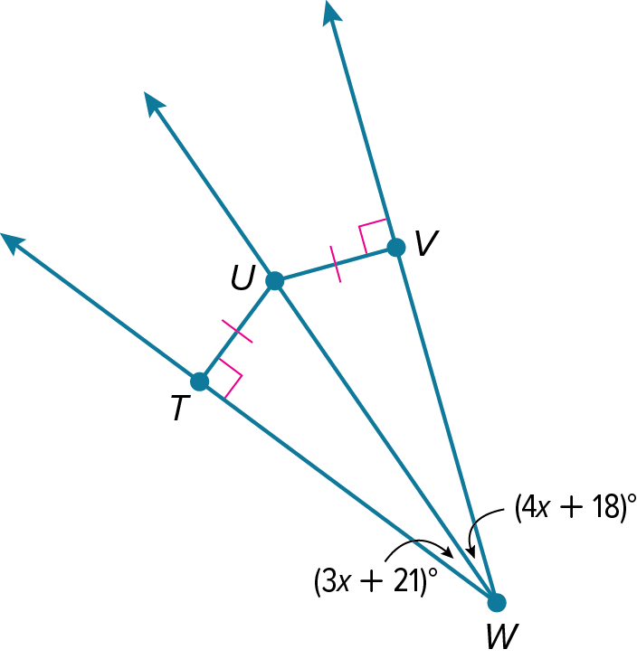

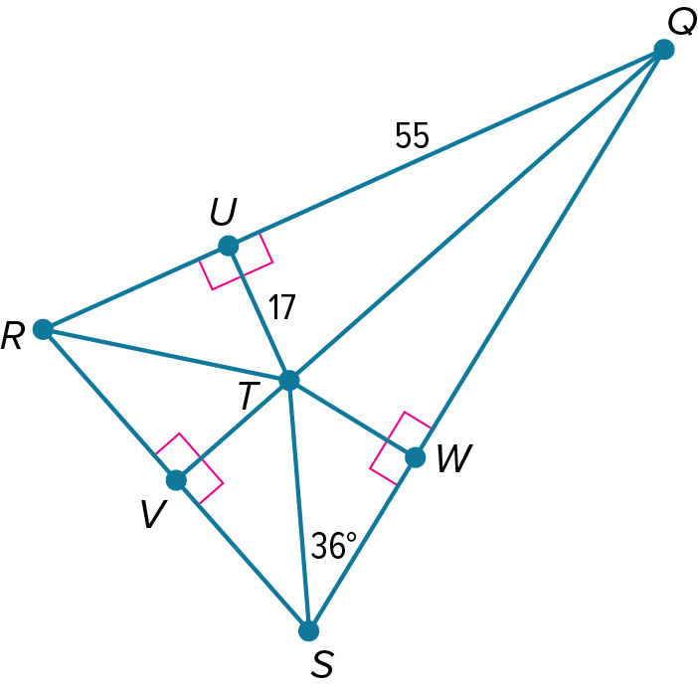
- T is the incenter of ∆QRS. Find each measure.
TW

m∠VST

QT (to the nearest tenth)

6-2 Exit Slip – Angle Bisectors
Name: _________________________________ Date:________ Period:________
- Find each measure.
find $m∠TWU$ find $m∠GDH$

- D is the incenter of ∆ABC. Find each measure.
m∠DBE

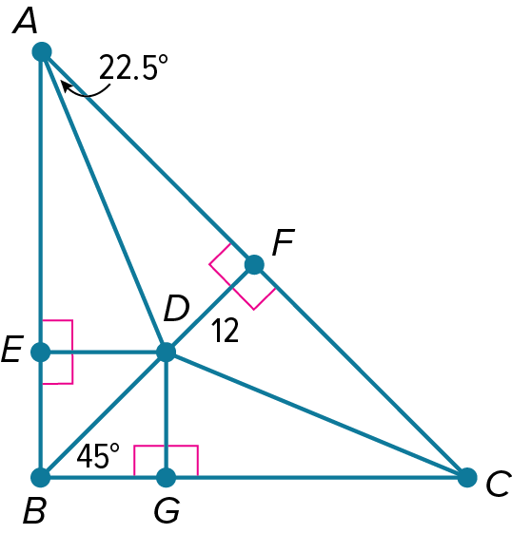
m∠FCD

ED

6-3 Opener – Medians and Altitudes of Triangles
Name: _________________________________ Date:________ Period:________
- In △QRS, W is the centroid, WQ = 35, TW = 20, and SU = 69. Find each measure.
Find VW
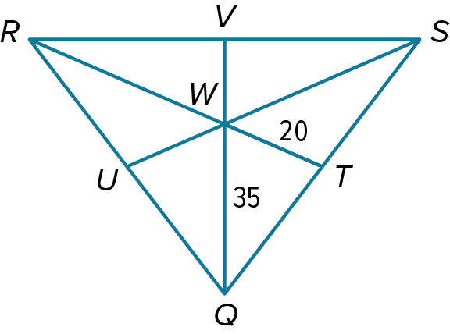

Find VQ

- Find the coordinates of the orthocenter of the triangle with the given vertices.
A(–1, –3), B(–1, 2), C(2, 3)

6-3 Exit Slip – Medians and Altitudes of Triangles
Name: _________________________________ Date:________ Period:________
- In △QRS, W is the centroid, WQ = 35, TW = 20, and SU = 69. Find each measure.
Find UW

Find RT

- Find the coordinates of the orthocenter of the triangle with the given vertices.
R(–5, 3), S(1, –3), T(2, 3)

6-4 Opener – Inequalities in One Triangle
Name: _________________________________ Date:________ Period:________
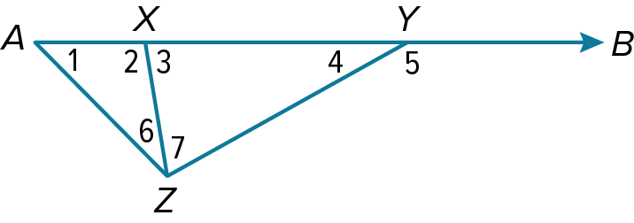
- List the angles that satisfy the stated condition.
measures are less than m∠3

measures are less than m∠5

- List the angles and sides of each triangle in order from smallest to largest.

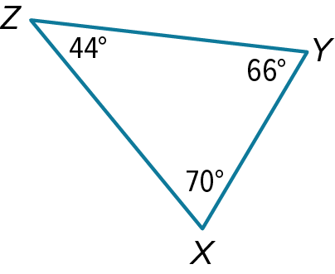
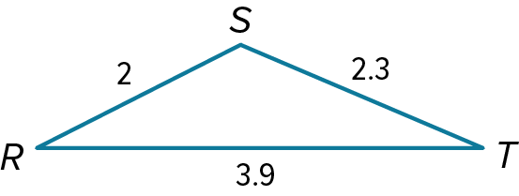

6-4 Exit Slip – Inequalities in One Triangle
Name: _________________________________ Date:________ Period:________
- List the angles that satisfy the stated condition.
measures are greater than m∠1

measures are less than m∠2

- List the angles and sides of each triangle in order from smallest to largest.
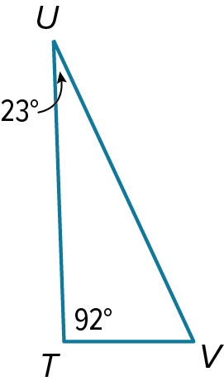
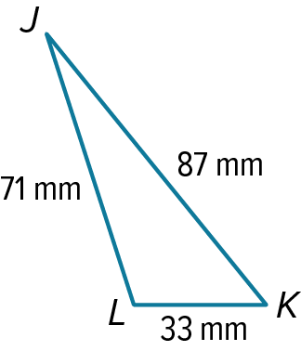

6-5 Opener – Indirect & Direct Proof (BONUS)
Name: _________________________________ Date:________ Period:________
- Write an indirect proof of each statement. Assume that x and y are integers.
If $x^{2}+ 2 ≤ 3$, then x ≤ 1.

Given: $xy^{2}$ is a negative integer.
Prove: x is a negative integer.

- Write a direct proof of each statement. Assume that x and y are integers.
Given: x is even, and y is odd.
Prove: $x⋅y$ is even.

Given: x is even, and y is even.
Prove: x+y+1 is an odd integer.

6-5 Exit Slip – Indirect & Direct Proof (BONUS)
Name: _________________________________ Date:________ Period:________
- Write an indirect proof of each statement.

If x – 4 > 0, then x > 4

Given: x is an odd integer, and y is an even integer.
Prove: x + y is an odd integer.

- Write a direct proof of each statement. Assume that x and y are integers.
Given: x is an odd integer, and y is an odd integer.
Prove: x - y is an even integer.

Given: x(x + 1) and x is an integer.
Prove: x(x+1) is always an even integer.

  - Opener – The Triangle Inequality
Name: _________________________________ Date:________ Period:________
Is it possible to form a triangle with the given side lengths? If not, explain why not.

3, 5, 8

2, 4, 5

Find the range for the measure of the third side of a triangle given the measures of two sides.
2 km and 42 km

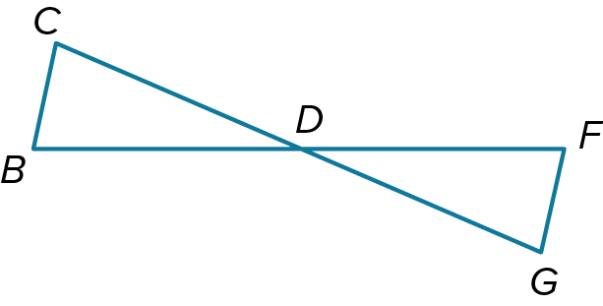
Write a two-column proof.
Given: $∆BCD≅∆FGD$
Prove: $CD+FG>DF$

6-6 Exit Slip – The Triangle Inequality
Name: _________________________________ Date:________ Period:________
Is it possible to form a triangle with the given side lengths? If not, explain why not.

250, 350, 500
7, 12, 22

Find the range for the measure of the third side of a triangle given the measures of two sides.
22 in. and 17 in

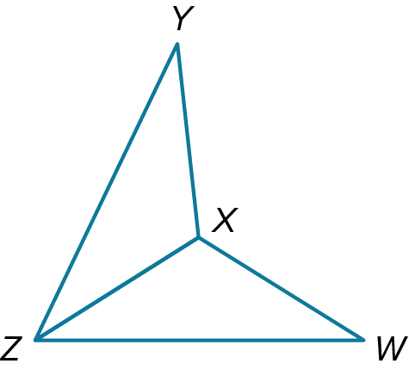
Write a two-column proof.
Given: $ZY≅ZW; ∠YZX≅∠WZX$
Prove: $ZX+XW>ZY$

  - Opener – Inequalities in Two Triangles
Name: _________________________________ Date:________ Period:________
Find the range of possible values for x.
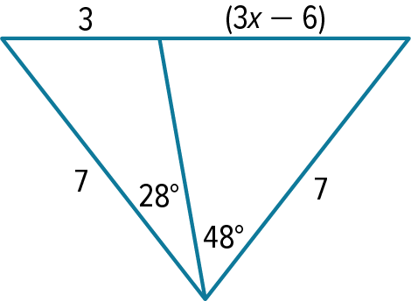
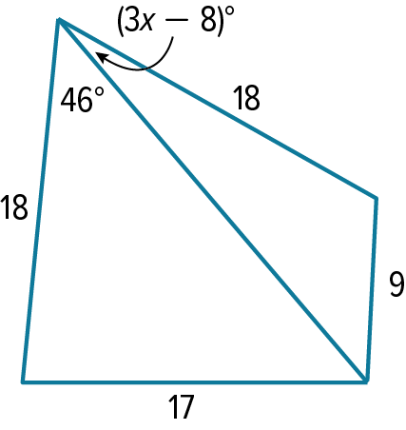

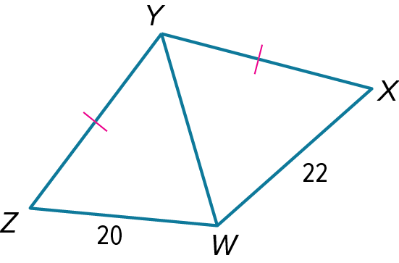
Write a two-column proof.
Given: $YX≅YZ; ZW = 20; WX = 22$
Prove: $m∠ZYW<m∠WYX$

6-7 Exit Slip – Inequalities in Two Triangles
Name: _________________________________ Date:________ Period:________
Find the range of possible values for x.

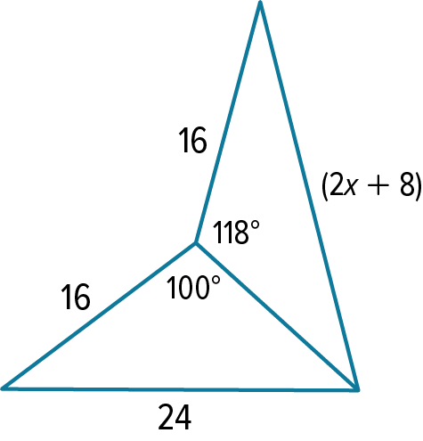
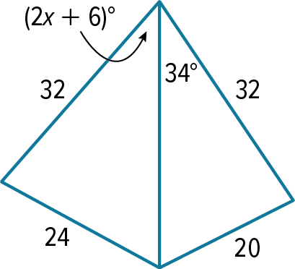

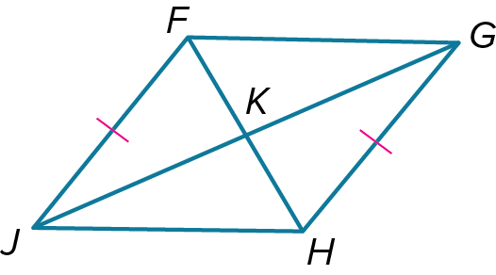
Write a two-column proof.
Given $JF≅HG; JH > GH; JF∥HG$
Prove: $m∠JKH>m∠GKH$

