9-1 Opener - Geometric Mean
Name: _________________________________ Date:________ Period:________
- Find the geometric mean between each pair of numbers.
25 and 27 18 and 7

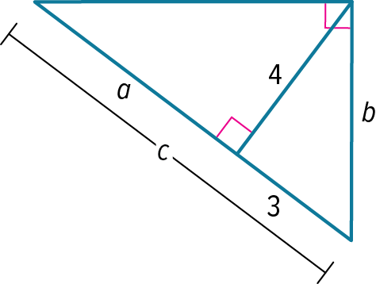
- Write a similarity statement identifying the three similar right triangles in each figure.
If given a, b, and c, find the values of a, b, and c.
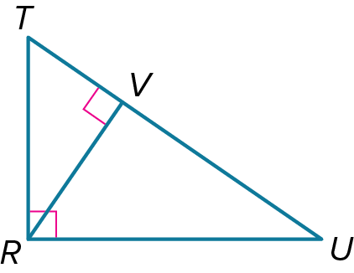

9-1 Exit Slip - Geometric Mean
Name: _________________________________ Date:________ Period:________
- Find the geometric mean between each pair of numbers.
13 and 17 2 and 19

- Write a similarity statement identifying the three similar right triangles in each figure.
If given a, b, and c, find the values of a, b, and c.
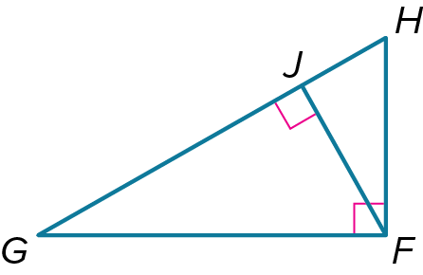
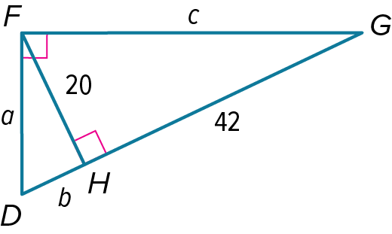

  - Opener – Pythagorean Theorem and Its Converse
Name: _________________________________ Date:________ Period:________
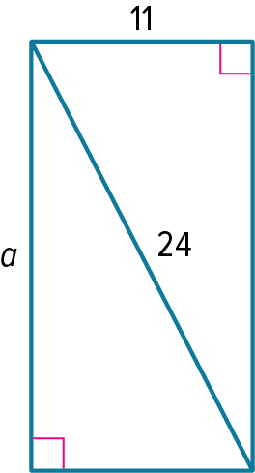
- Find the value of a.

- Use a Pythagorean Triple to find the value of a.
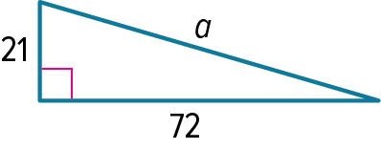

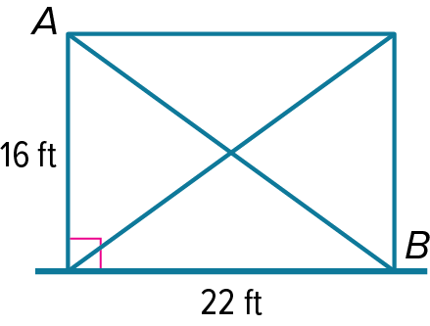
CABLE BRACING The steel structure shown is made of vertical columns and a horizontal beam. Steel cables are installed to prevent the structure from tilting over and collapsing. What is the length of cable AB?

9-2 Exit Slip – Pythagorean Theorem and Its Converse
Name: _________________________________ Date:________ Period:________
- Find the value of a.
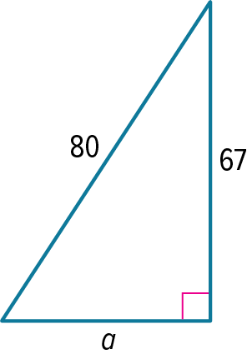

- Use a Pythagorean Triple to find the value of a.
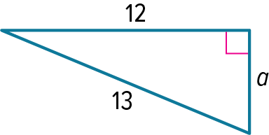

LADDER A ladder is placed against a wall such that the top is 8 feet above the ground. If the ladder is 10 feet long, how far away from the wall is the base of the ladder?

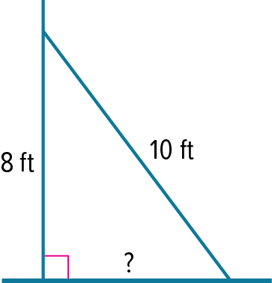

9-3 Opener – Coordinates in Space
Name: _________________________________ Date:________ Period:________
- Graph a rectangular solid that contains the given point and the origin as vertices.
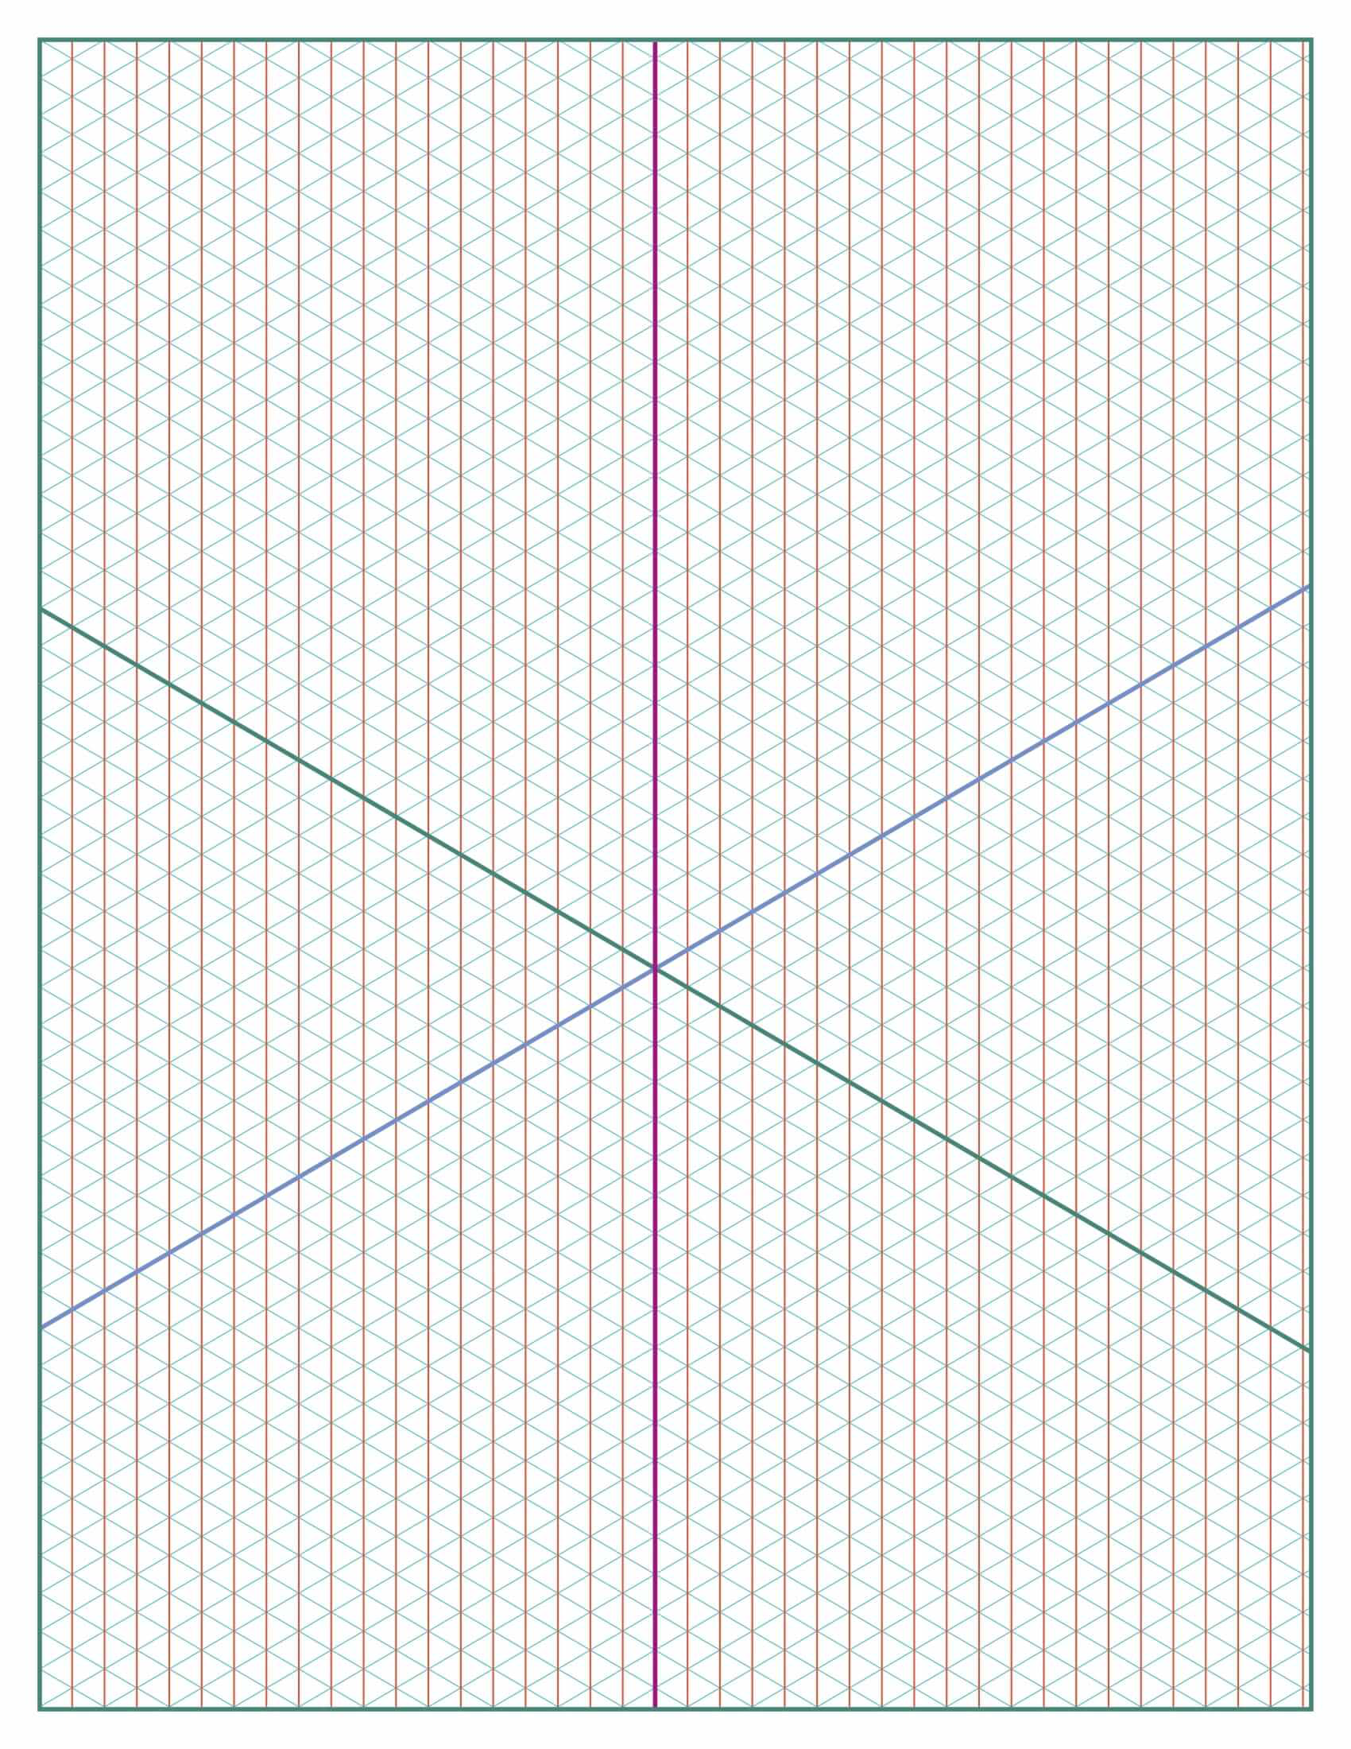
Label the coordinates of each vertex.
G(–2, 4, 3)

- Determine the distance between each pair of points.
W(2, –4, 3) and X(9, 2, 8)

- Determine the coordinates of the midpoint M of the segment joining each pair of points.
W(2, –4, 3) and X(10, 2, 9)

9-3 Exit Slip – Coordinates in Space
Name: _________________________________ Date:________ Period:________
- Graph a rectangular solid that contains the given point and the origin as vertices.
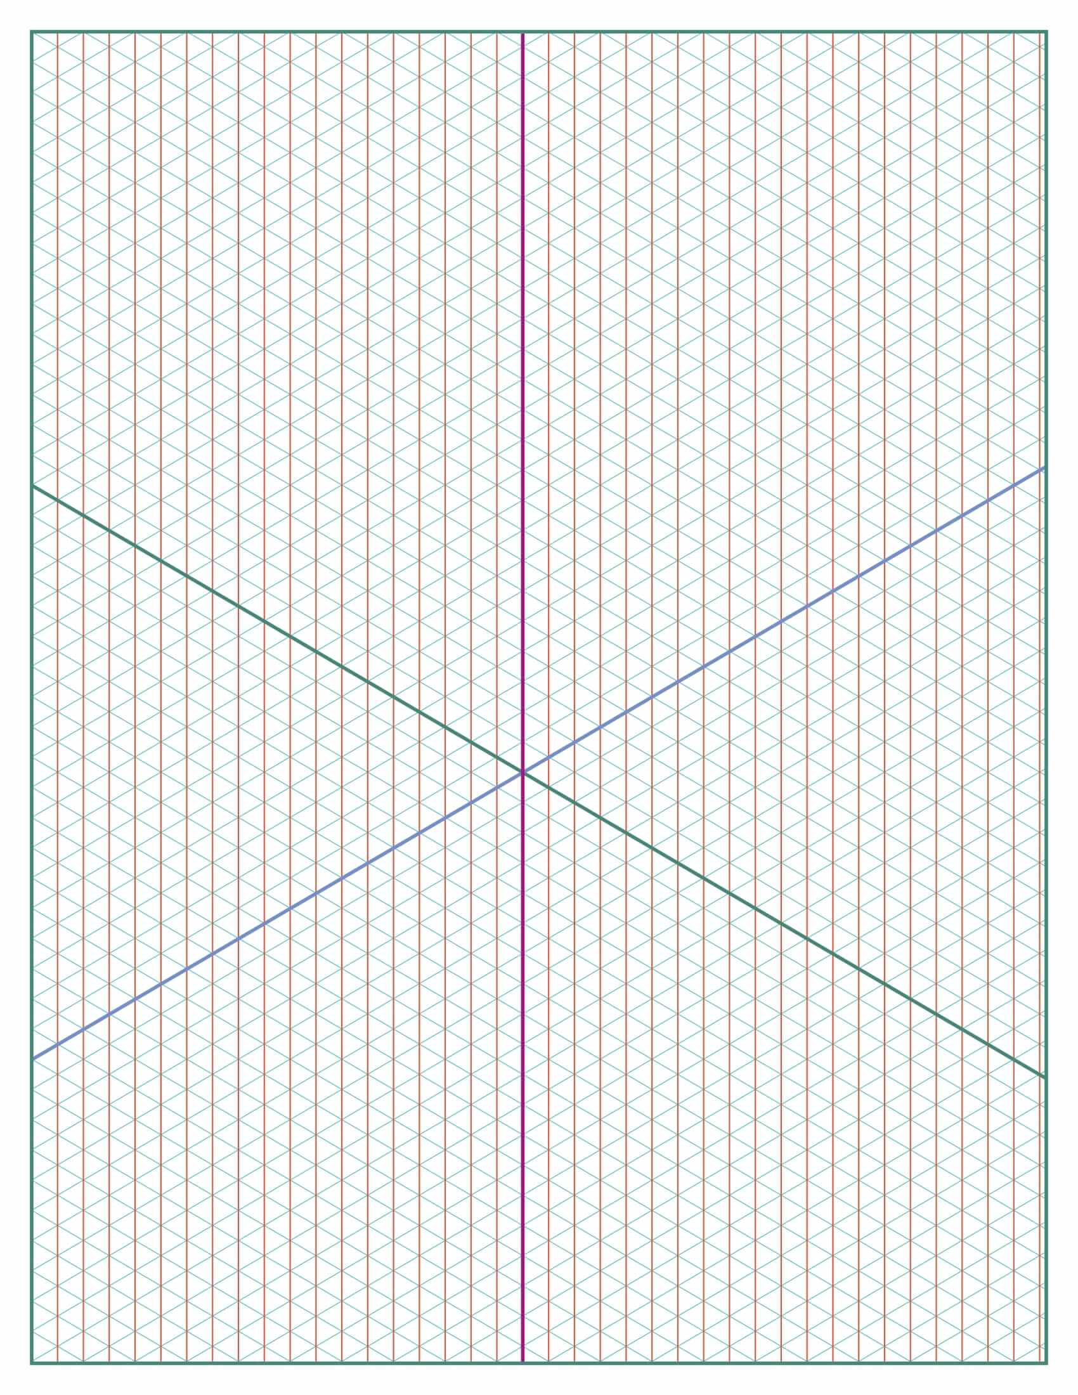
Label the coordinates of each vertex.
B(2, –2, 3)

- Determine the distance between each pair of points.
L(1, 4, 7) and M(2, 9, 8)

- Determine the coordinates of the midpoint M of the segment joining each pair of points.
F(5, 5, 1) and G(7, 3, 11)

9-4 Opener – Special Right Triangles
Name: _________________________________ Date:________ Period:________
- Find the value of x.

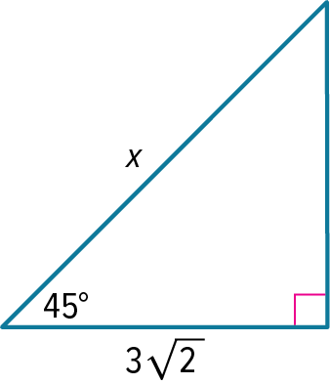
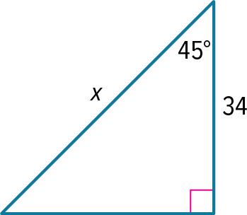

- Find the values of x and y.
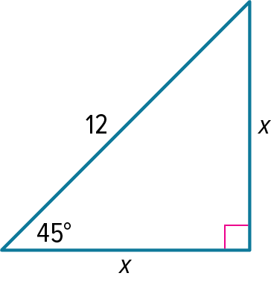
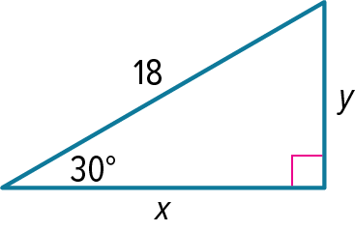

9-4 Exit Slip – Special Right Triangles
Name: _________________________________ Date:________ Period:________
- Find the value of x.
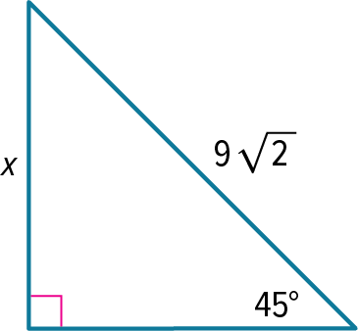
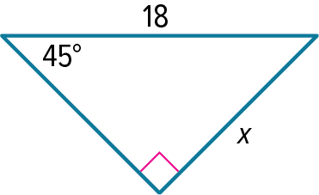

- Find the values of x and y.
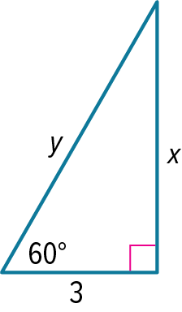

9-5 Opener – Trigonometry
Name: _________________________________ Date:________ Period:________
- Find sin A, cos A, tan A, sin B, cos B, and tan B. Express each ratio as a fraction and as a decimal to the nearest hundredth.
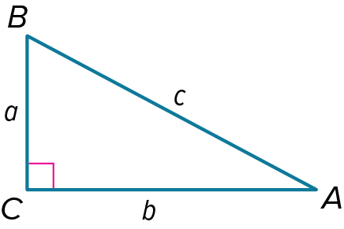
a = 8, b = 15, c = 17

- Solve each right triangle. Round side measures to the nearest tenth and angle measures to the nearest degree.
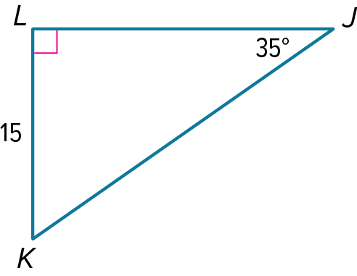

9-5 Exit Slip – Trigonometry
Name: _________________________________ Date:________ Period:________
- Find sin A, cos A, tan A, sin B, cos B, and tan B. Express each ratio as a fraction and as a decimal to the nearest hundredth.
a = 21, b = 28, c = 35

- Solve each right triangle. Round side measures to the nearest tenth and angle measures to the nearest degree.
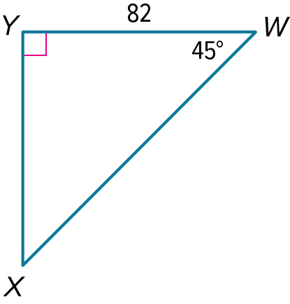

9-6 Opener – Applying Trigonometry
Name: _________________________________ Date:________ Period:________
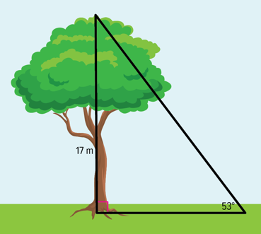
- TREE HEIGHT Carrie is told that a tree is 17 meters high. If the angle from where she is standing to the top of the tree is 53°, how far from the tree is she standing? Round your answer to the nearest tenth.

- Use trigonometry to find the area of ∆XYZ to the nearest tenth.
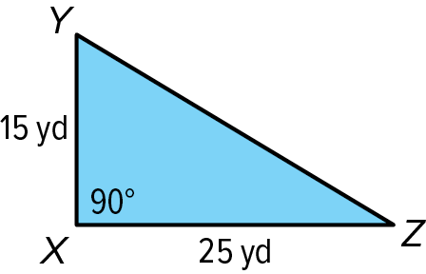
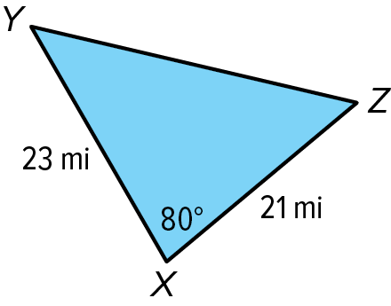

9-6 Exit Slip – Applying Trigonometry
Name: _________________________________ Date:________ Period:________
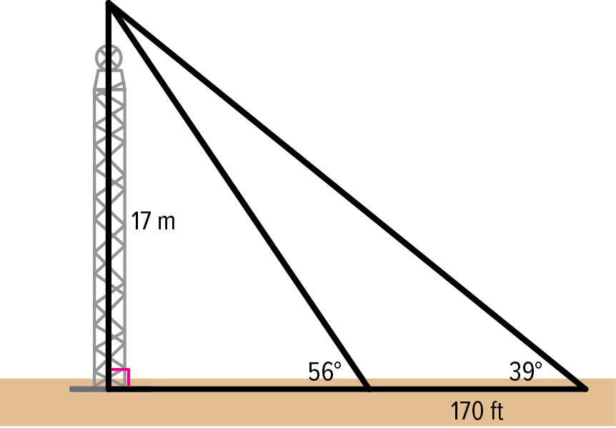
- RADIO TOWER The angle from the ground to the top of a radio tower is 56°. At a point 170 feet farther back, the angle from the ground to the top of the tower is 39°. How far is the first point from the base of the tower? Round your answer to the nearest tenth.

- Use trigonometry to find the area of ∆XYZ to the nearest tenth.
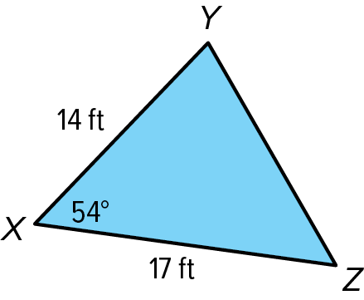
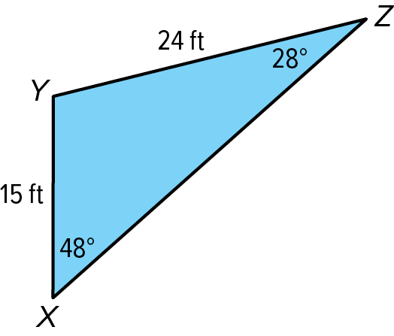

9-7 Opener – Law of Sines
Name: _________________________________ Date:________ Period:________
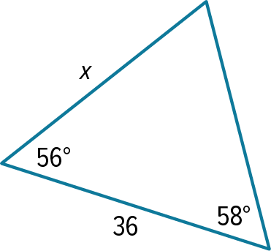
- Find the value of x to the nearest tenth.
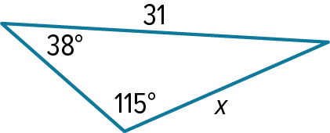

- Determine whether each triangle has no solution, one solution, or two solutions.
m∠R=136°, r = 13, s = 8

9-7 Exit Slip – Law of Sines
Name: _________________________________ Date:________ Period:________
- Find the value of x to the nearest tenth.
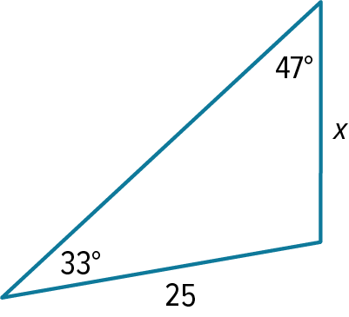
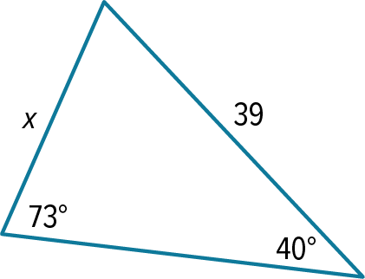

- Determine whether each triangle has no solution, one solution, or two solutions.
m∠R=52°, r = 14, s = 16

9-8 Opener – Law of Cosines
Name: _________________________________ Date:________ Period:________
- Find the value of x to the nearest tenth for side lengths and nearest degree for angle measures.
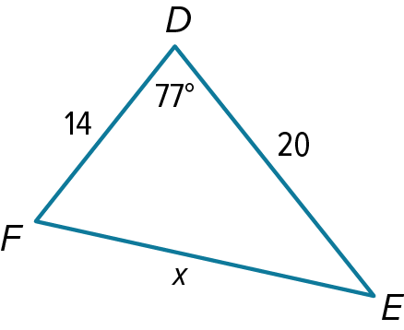
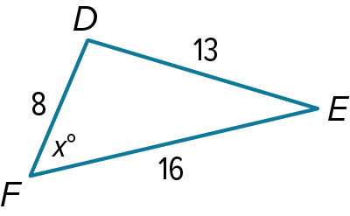

- Solve each triangle. Round side lengths to the nearest tenth and angle measures to the nearest degree.

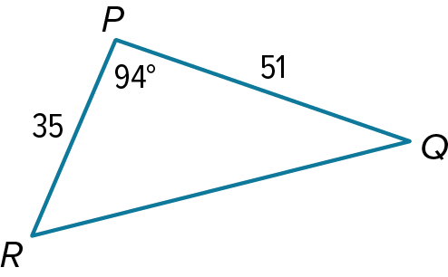

9-8 Exit Slip – Law of Cosines
Name: _________________________________ Date:________ Period:________
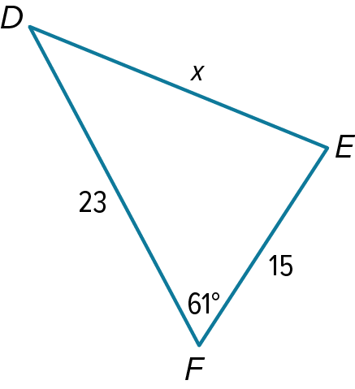
- Find the value of x to the nearest tenth for side lengths and nearest degree for angle measures.
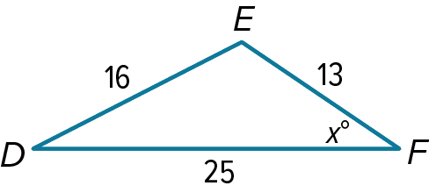

- Solve each triangle. Round side lengths to the nearest tenth and angle measures to the nearest degree.
