Consumer Math ~ 2024-2025

Mr. Cole Held *Room A102*

*If you have any questions, please contact me via e****-mail*:** cheld@eriesd.org

# *Erie High School Royals are RESPECTFUL, RESPONSIBLE, and RESILIENT.*

| **DAILY Class Materials** | | | | |
| --- | --- | --- | --- | --- |
| Folder containing warm-ups and module pages | | Pencil/pen | Lined Paper | Chromebook / Calculator |
|  | | | | |

**Course** Basic Math Skills: Review of fundamental arithmetic operations (addition, subtraction, multiplication, division) and their application to financial calculations.

Personal Budgeting: Creating and managing budgets to track income, expenses, and savings.

Banking: Understanding different types of bank accounts, interest rates, and financial transactions.

Loans and Credit: Exploring various types of loans (e.g., mortgages, car loans), credit scores, and interest rates.

Investments: Introduction to investing concepts, including stocks, bonds, and savings accounts.

Taxes: Understanding basic tax principles, filing requirements, and tax deductions.

Shopping and Consumerism: Evaluating prices, discounts, and sales to make informed purchasing decisions.

Insurance: Exploring different types of insurance (e.g., health, auto, homeowners) and their costs.

Financial Planning: Developing long-term financial goals, such as retirement planning and education savings.

**Cheating and Plagiarism Policy**

* Copying of other students’ work on assignments or any other assessments; the use of AI (artificial intelligence) or other software to generate answers; or any other forms of cheating or plagiarism shall result in an immediate zero (0) for the assignment and may result in the student being referred for further disciplinary action.

**Class Rules**

Students are expected to follow the class rules which include:

* *Rule #1:*  Be Respectful
* *Rule #2:* Be Responsible
* *Rule #3:* Be Resilient

Consequences for breaking rules will include: verbal warnings, contact with home, after-school detention, and/or referral to administration.

***The overarching goal of this class is to learn Algebra and to pass!!***

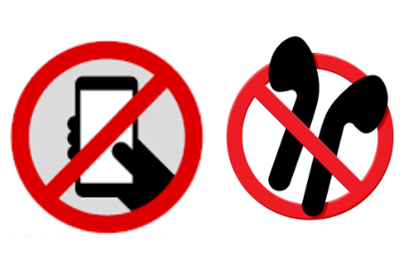

**Cell Phone Policy**

Personal Electronic Communication Devices must be turned off upon entering any instructional area and remain off until the student leaves the instructional area.

First violation: Verbal warning

Second violation: Verbal warning

Third violation: Administration will be called to confiscate as outlined in the EHS Student Handbook (see pages 40-43). Your cell phone will then be kept in the office until the end of the school day.

# ***Extra help is available each Monday after school***

| **COURSE GRADE** | | | | |
| --- | --- | --- | --- | --- |
|  | **Tests / Quizzes** | | **DO NOW/Participation** | **Classwork/Projects** |
| % of  Course Grade | 20% | | 20% | 60% |
| Retakes | Tests are given at the end of each unit/module. You may retake tests, provided the retake requirements are met. In order to retake a test, the related assignments must be 100% complete and students must do test corrections and/or attend after school help.  Students must have retakes completed within the same quarter grading period as the test is given, provided they meet the retake requirements.  . | | Unable to retake, but opportunities will be presented to make up points. | Students will complete warm-ups and guided notes in a provided folder.  Classwork will include warm-ups, notes, participation, and group tasks or projects completed during class time. |
| Absences | Students who are absent on the original test day **WILL** take the test the day they return to school.  . | | Alternative assignments. | ✓ Homework should be completed the night it is assigned or turned in at the beginning of next class.  ✓ Online assignments will have posted DUE dates.  ✓ Paper assignments will be collected in a weekly HW packet (usually each Friday) in the “turn it in bin”.  ✓ Students who wish to turn in late HW packet assignments must attend after school tutoring.  ✓ Late work will not be accepted after the conclusion of each quarter. |

The overall grading scale is: A= 90-100%, B= 80-89%, C= 70-79% , D= 65-69%, F= 0-64%

Extra credit is **not** available to improve your grade. Occasionally extra credit work will be available and if you want extra points added to your grade, take advantage of extra credit when it is offered.

*\*This syllabus is subject to change as the semester progresses. Updates will be posted in Schoology.*