3-1 Opener - Conjectures and Counterexamples
Name: _________________________________ Date:________ Period:________
- Write a conjecture that describes the pattern in each sequence. Then use your conjecture to find the next term in the sequence.
1, 10, 100, 1000, 10,000

2, 4, 8, 16, 32

- Make a conjecture about each value or geometric relationship.

The product of two and a whole number, plus two.

The relationship between the surface area of a cube and the area of one face of the same cube.

3-1 Exit Slip - Conjectures and Counterexamples
Name: _________________________________ Date:________ Period:________
- Write a conjecture that describes the pattern in each sequence. Then use your conjecture to find the next term in the sequence.
1, 3, 5, 7, 9, 11

$\frac{1}{2}$, 1, $\frac{3}{2}$, 2, $\frac{5}{2}$

2) Make a conjecture about each value or geometric relationship.

The product of two and a whole number, plus one.

The relationship between x and y if x+y =0

3-2 Opener – Statements, Conditionals, and Biconditionals
Name: _________________________________ Date:________ Period:________
- Use the statements to write a compound statement for each conjunction or disjunction.
p: $-7+3=-4$ q: The sum of complementary angles is 90°. r: $3-4=-1$
$\sim q∧p$ $p∨\sim r$

- Identify the hypothesis and conclusion of each conditional statement. If the statement is not in if-then form, then write the statement in that form.
The area of a triangle is $\frac{1}{2}bh$.

Everyone in geometry class was given a book.

- Write the inverse, converse, and contrapositive of the statement:
DINNER PARTY If José has eight dinner plates, then he can serve eight people at his dinner party.

3-2 Exit Slip – Statements, Conditionals, and Biconditionals
Name: _________________________________ Date:________ Period:________
- Use the statements to write a compound statement for each conjunction or disjunction.
p: $x$is an even number q: The number of degrees in a circle is 360°. r: $x-3=15$
$p and r$ $\sim p∨q$

- Identify the hypothesis and conclusion of each conditional statement. If the statement is not in if-then form, then write the statement in that form.
If I am sleepy, then I have not had enough sleep.

Supplementary angles add up to 180°.

3) Write the inverse, converse, and contrapositive of the statement:
STUDENT CENTER A teacher tells a class, “If your last name begins with A to M, then you go to the student center.”

3-3 Opener – Deductive Reasoning
Name: _________________________________ Date:________ Period:________
- Determine whether each conclusion is based on inductive or deductive reasoning.
Whenever Bob studies, he makes good grades on his tests. Bob studies for a test. He thinks he will make a good grade.

Joan cannot attend a friend’s birthday party if she is sick. Joan is sick. She cannot attend the birthday party.

- Determine whether each conclusion is valid based on the given information. Write valid or invalid. Explain your reasoning.

Given: If a boat has a hole in its hull, the boat will sink.
The boat has a hole in its hull.
Conclusion: The boat will sink.

- Use the Law of Syllogism to draw a valid conclusion from each set of given statements, if possible. If no valid conclusion can be drawn, write no valid conclusion and explain your reasoning.
If two lines are parallel, then they are on the same plane.
If two lines are parallel, then they have the same slope.

3-3 Exit Slip – Deductive Reasoning
Name: _________________________________ Date:________ Period:________

- Determine whether each conclusion is based on inductive or deductive reasoning.
Cheerleaders can only practice outside when the weather is clear. It is raining today, so the cheerleaders cannot practice outside.

Everybody who goes to camp must have a physical exam. Carl goes to camp. Carl had a physical exam.

- Determine whether each conclusion is valid based on the given information. Write valid or invalid. Explain your reasoning.

Given: If you eat at a restaurant, then you will spend money.
You spend money.
Conclusion: You are eating at a restaurant.

- Use the Law of Syllogism to draw a valid conclusion from each set of given statements, if possible. If no valid conclusion can be drawn, write no valid conclusion and explain your reasoning.
If a majority of the student body votes for James, he will be elected class president.
If James is elected class president, he will speak at graduation.

3-4 Opener – Writing Proofs
Name: _________________________________ Date:________ Period:________
1) Determine if the statement is always, sometimes, or never true. Justify your argument.
Lines a and b intersect at exactly one point.

2) Complete the two-column proof.
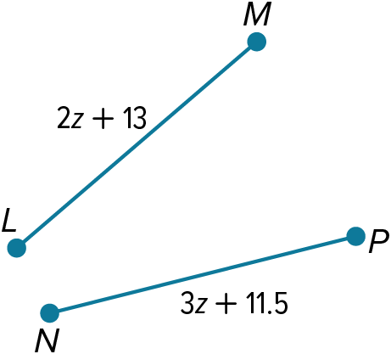
Given: $\overline{LM}≅ \overline{NP}$ Prove: z = 1.5
Statements | Reasons
1. ___________________ | 1. Given
2. LM = NP | 2. ___________________
3. ___________________ | 3. Substitution Property of Equality
4. ___________________ | 4. Subtraction Property of Equality
5. 1.5 = z | 5. Subtraction Property of Equality
6. z = 1.5 | 6. ___________________

3-4 Exit Slip – Writing Proofs
Name: _________________________________ Date:________ Period:________
1) Determine if the statement is always, sometimes, or never true. Justify your argument.
Point B is an equal distance from point A and point C. Point B is the midpoint of AC.

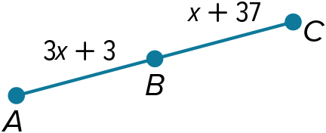
- Complete the two-column proof.
Given: B is the midpoint of AC. Prove: x = 17
Statements | Reasons
1. B is the midpoint of AC. | 1. ______________________
2. ______________________ | 2. Definition of midpoint
3. ______________________ | 3. Definition of congruent segments
4. 3x + 3 = x + 37 | 4. ______________________
5. ______________________ | 5. Subtraction Property of Equality
6. 2x = 34 | 6. ______________________ `
7. ______________________ | 7. Division Property of Equality
3-5 Opener – Proving Segment Relationships
Name: _________________________________ Date:________ Period:________
- Write the correct statements and reasons to complete the two-column proof.
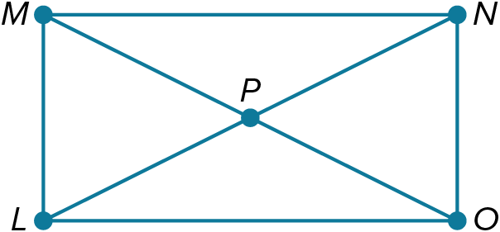
Given: MP≅LP, LN≅MO Prove: PN = PO
Proof:
Statements | Reasons
1. MP≅LP  LN≅MO | 1. _____________________
2. _____________________ | 2. Definition of ≅ segments
3. MO = MP + PO  LN = LP + PN | 3. _____________________
4. LP + PN = MP + PO | 4. _____________________
5. LP + PN = LP + PO | 5. _____________________
6. _____________________ | 6. Subtraction Property of Equality

3-5 Exit Slip – Proving Segment Relationships
Name: _________________________________ Date:________ Period:________
- Write the correct statements and reasons to complete the two-column proof.
Given: XY≅WU, XZ≅ZU Prove: YZ≅ZW
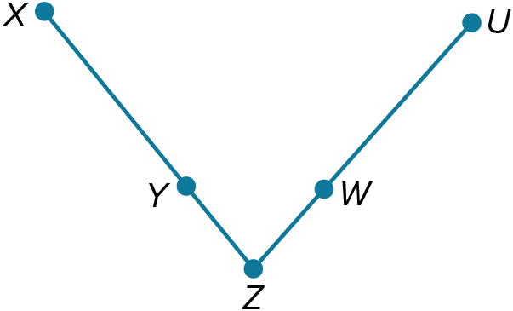
Proof:
Statements | Reasons
1. _____________________ | 1. Given
2. _____________________ | 2. Definition of ≅ segments
3. XZ = XY + YZ  ZU = ZW + WU | 3. _____________________
4. _____________________ | 4. Substitution Property
5. _____________________ | 5. Substitution Property
6. YZ = ZW | 6. _____________________
7. YZ≅ZW | 7. _____________________

3-6 Opener – Proving Angle Relationships
Name: _________________________________ Date:________ Period:________
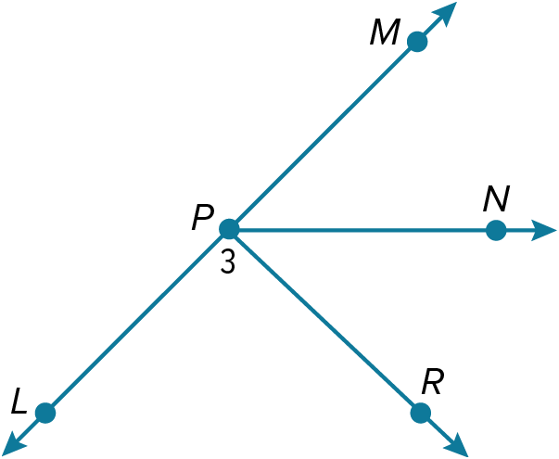
- Find the measure of each angle.
If $m∠MPN=39$° and $m∠RPN=54°,$ find $m∠3$.

Find $m∠RPN$ if $m∠MPN=35$° and $m∠3=90°$

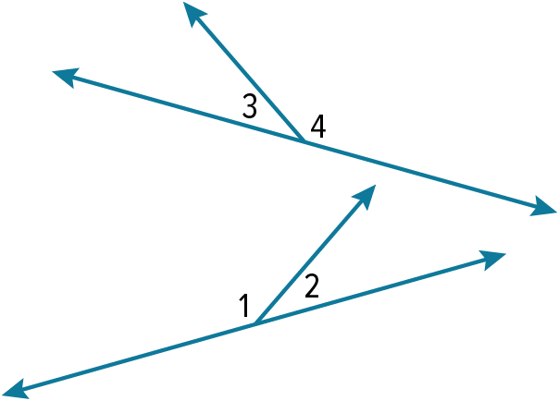
- Write a two column proof.
Given: ∠1≅∠4
Prove: ∠2≅∠3

3-6 Exit Slip – Proving Angle Relationships
Name: _________________________________ Date:________ Period:________
- Find the measure of each angle.
Find $m∠LPN$ if $∠3$ is a right angle and $∠MPN≅∠RPN$.

If $m∠LPN=132°$ and $m∠RPN=37°,$ find $m∠3$.

- Write a two column proof.
Given: ∠4≅∠2
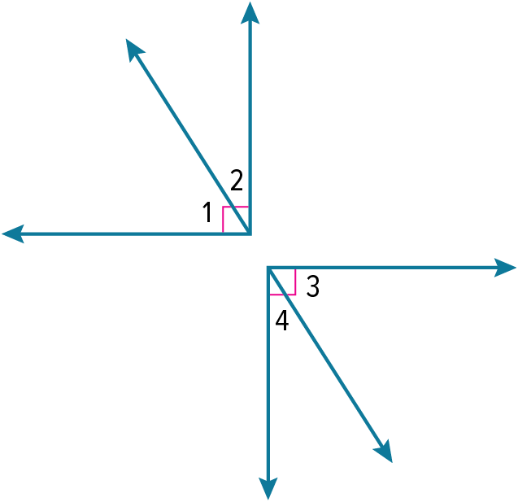
Prove: ∠1≅∠3

3-7 Opener – Parallel Lines and Transversals
Name: _________________________________ Date:________ Period:________
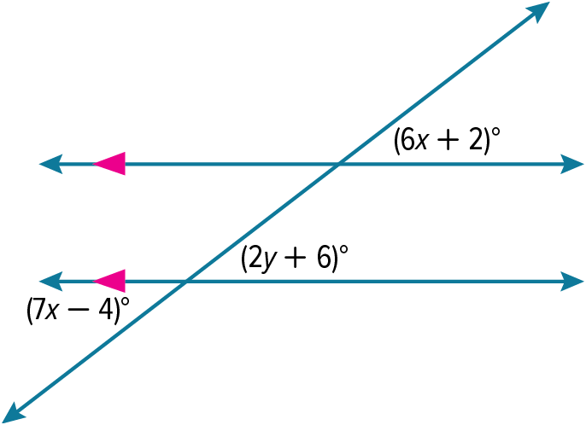
1) Find the value of each variable. Explain your reasoning.

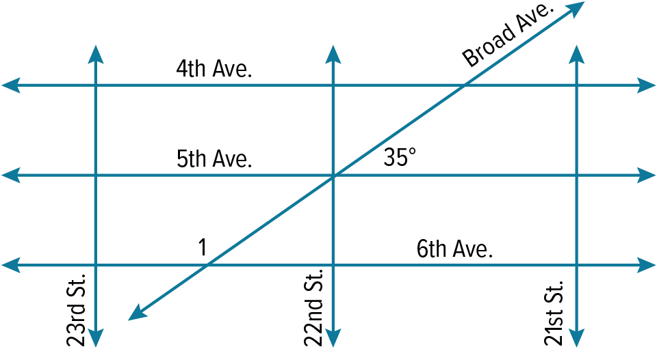
CITY STREETS Avenues and streets in a city run perpendicular to each other, forming a grid. However, newly constructed Broad Avenue will run at a 35° angle to the other avenues. Assuming that all streets are parallel and that all avenues are parallel, what is the measure of angle 1?

3-7 Exit Slip – Parallel Lines and Transversals
Name: _________________________________ Date:________ Period:________
- Find the value of each variable. Explain your reasoning.
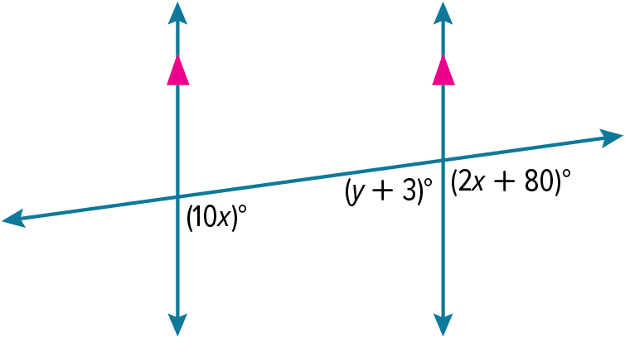

LADDERS A construction worker leans a ladder against the top of a building so that it forms a 132° angle with the ground, as shown in the figure. What is the measure of angle 1, which is the angle formed by the ladder and the top of the building?
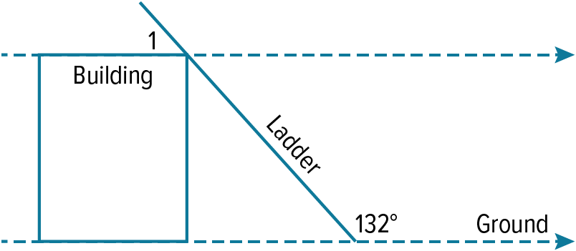

3-8 Opener – Slope and Equations of Lines
Name: _________________________________ Date:________ Period:________
Determine whether $\overset{⃡}{AB}$ and $\overset{⃡}{CD}$ are parallel, perpendicular, or neither.
A(–1, 3), B(1, 1), C(1, –3), D(2, 2) A(–6, 8), B(–4, –2), C(6, 4), D(8, –6)

Determine whether each pair of lines are parallel, perpendicular, or neither.
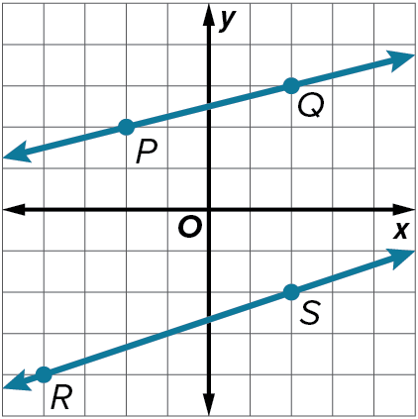

$y = 4x – 5, y+2=-\frac{1}{4}(x-5)$

3-8 Exit Slip – Slope and Equations of Lines
Name: _________________________________ Date:________ Period:________
Determine whether $\overset{⃡}{AB}$ and $\overset{⃡}{CD}$ are parallel, perpendicular, or neither.
A(–6, 2), B(–4, 8), C(0, –4), D(2, 2) A(–2, 2), B(4, 4), C(–1, 4), D(1, –2)

Determine whether each pair of lines are parallel, perpendicular, or neither.
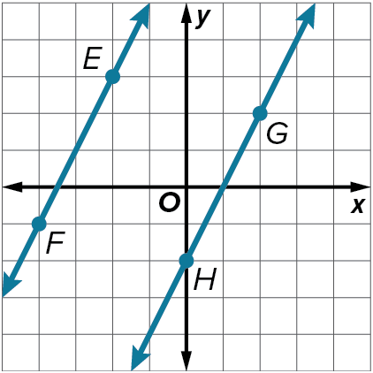
$x = 7, y = –3$*Hint draw a picture*

3-9 Opener – Proving Lines Parallel
Name: _________________________________ Date:________ Period:________
- Use the given information to determine which lines, if any, are parallel. State the postulate or theorem that justifies your answer.
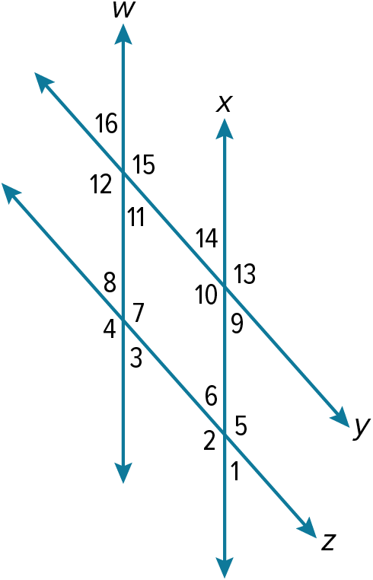

- $∠15≅∠13$

- $m∠6+m∠7=180°$

- $∠16≅∠3$

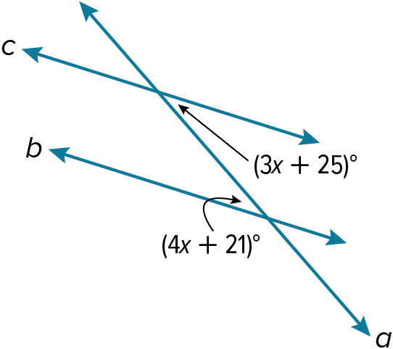
- Find the value of x so that $b∥c$.
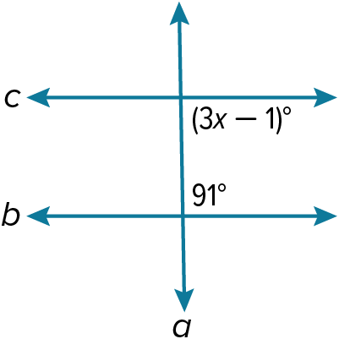

3-9 Exit Slip – Proving Lines Parallel
Name: _________________________________ Date:________ Period:________
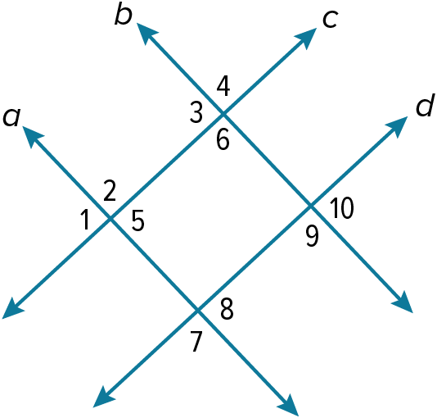
- Use the given information to determine which lines, if any, are parallel. State the postulate or theorem that justifies your answer.

- $m∠5+m∠6=180°$

- $∠4≅∠9$

- Find the value of $x$ so that $b∥c$.
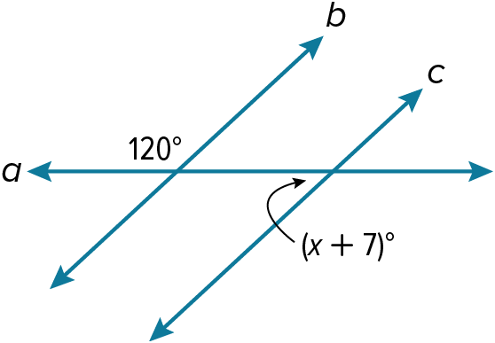
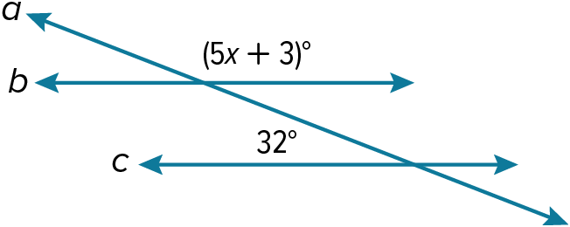

3-10 Opener – Perpendiculars and Distance
Name: _________________________________ Date:________ Period:________
- Find the distance between point $P$ and line $l$.
Line $l$ contains points $(3, 2)$ and $(7, –1).$ Point$P$ has coordinates $(2, 9)$.

- Find the distance between each pair of parallel lines with the given equation.

A B
$$y = x + 5$$
$$y = x + 11$$

$$x = –8$$
$$x = 9$$

3-10 Exit Slip – Perpendiculars and Distance
Name: _________________________________ Date:________ Period:________
- Find the distance between point $P$ and line $l$.
Line $l$ contains points $(3, –9)$ and $(4, –11)$. Point P has coordinates $(4, 4)$.

- Find the distance between each pair of parallel lines with the given equation

A B
$$y = -5x- 11$$
$$y = -5x+ 15$$

$$y=12$$
$$y=-3$$

