1-1 Opener - The Geometric System
Name: _________________________________ Date:________ Period:________
- Use the axioms to make three conclusions about the high school track meet.
RUNNING TRACK The Purple Hurricanes high school track team has 8 boys and 8 girls. The girls wear gold track suits, and the boys wear purple. Everyone competed in Thursday’s track meet. All members of the other team wore green suits.
• The Hurricanes won 3 first-place finishes.
• Two winners wore purple suits.
• There were 8 races in all, which included 4 boys and 4 girls.

- Classify each figure as either synthetic geometry or analytic geometry.
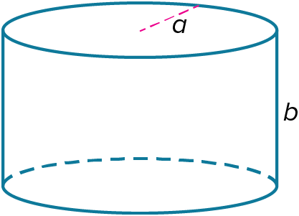
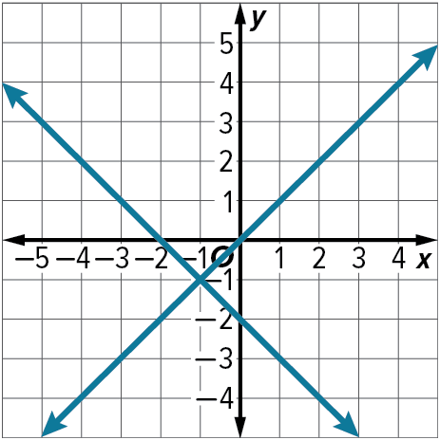
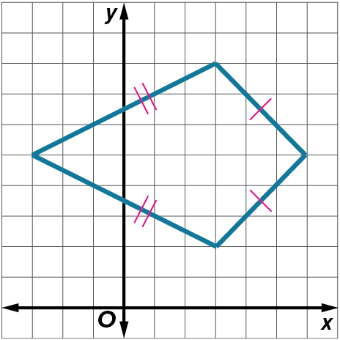

1-1 Exit Slip - The Geometric System
Name: _________________________________ Date:________ Period:________
- Use the axioms to make one conclusion about the pizzas, subs, and sodas.
PIZZERIA Magi’s Pizzeria serves pizzas and subs. Magi made 100 pizzas and 100 subs on Saturday. He earned $1700 this day.
• A sub costs half as much as a pizza.
• Magi sold all the pizzas and subs he made.
• He sold 200 sodas at $1 each.

- Classify the following figures as analytic geometry or synthetic geometry.
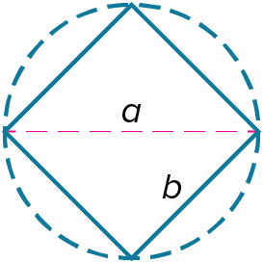
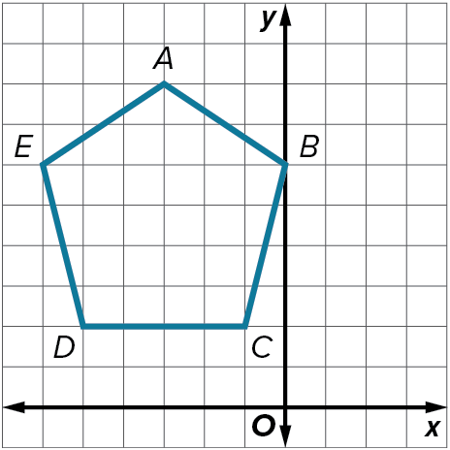
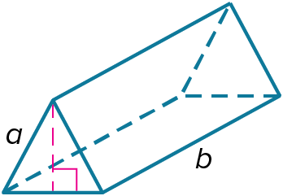

1-2 Opener – Points, Lines, and Planes
Name: _________________________________ Date:________ Period:________
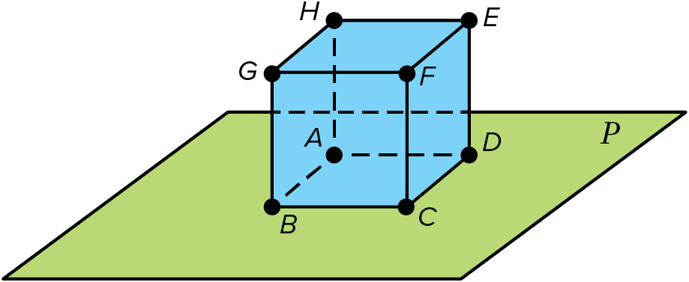
Use the figure to answer the questions.
- How many planes are shown in the figure?

- Which side of the cube is coplanar with plane P?

Name the geometric terms modeled by each figure.


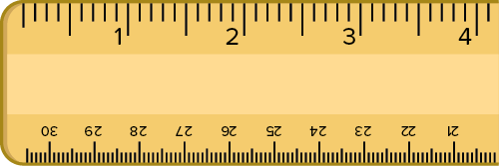

1-2 Exit Slip – Points, Lines, and Planes
Name: _________________________________ Date:________ Period:________
1) Draw and label a figure for the following statement. Points P, Q, and R lie on $\overset{⃡}{KL}$.

2) Name the geometric terms modeled by each figure.


Light pole

1-3 Opener – Line Segments
Name: _________________________________ Date:________ Period:________
- Find the measure of each segment.
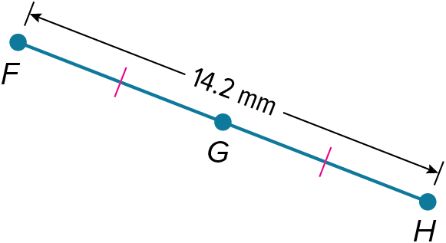
$\overline{FG}$
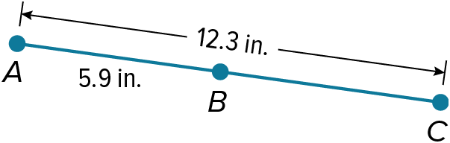
$\overline{BC}$

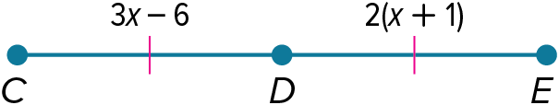 $\overline{CD}$

- Find the value of the variable and YZ if Y is between X and Z.
XY = 3p, YZ = 2p – 1, XZ = 6p – 6

XY = 32, YZ = 7d, XZ = 74

1-3 Exit Slip – Line Segments
Name: _________________________________ Date:________ Period:________
- Find the measure of each segment.
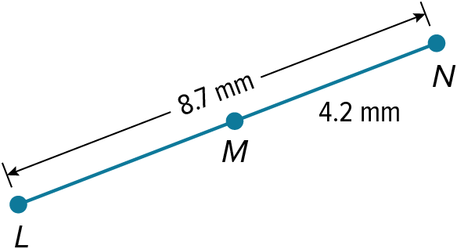
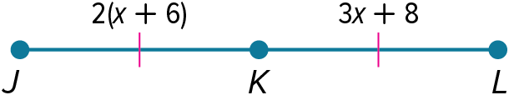
$\overline{LM}$ $\overline{JL }$

- Find the value of the variable and YZ if Y is between X and Z.

XY = 9m – 3, YZ = 6m + 1, XZ = 13m + 6

1-4 Opener – Distance
Name: _________________________________ Date:________ Period:________
1) Use the number line to find each measure.

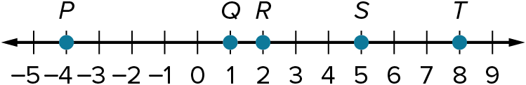

$PR$ $ST$ $QS$

2) Determine whether the given segments are congruent.
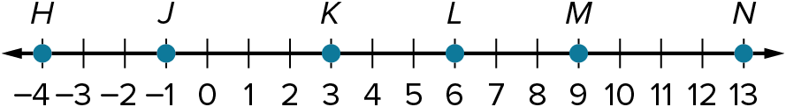

$\overline{JK}$ and $\overline{MN}$ $\overline{HK}$ and $\overline{KN}$

- Find the distance between the two points.
$L(3, 7)$ and $M(–2, 8)$

1-4 Exit Slip - Distance
Name: _________________________________ Date:________ Period:________
1) Use the number line to find each measure.

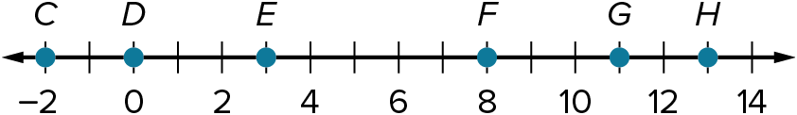

$GC$ $DH$ $GE$

2) Determine whether the given segments are congruent.

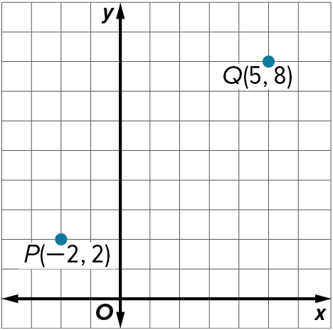

$\overline{ML}$ and $\overline{HJ}$

- Find the distance of the points on the graph.

1-5 Opener – Locating Points on Number Lines
Name: _________________________________ Date:________ Period:________
- Use the number line to answer the questions:
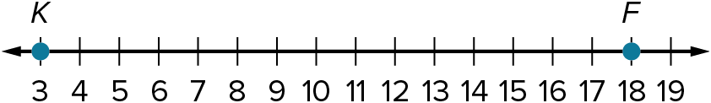

Find the coordinate of point N that is $\frac{1}{5}$of the distance from K to F.

Find the coordinate of point M such that the ratio of $\overline{KM }$to $\overline{MF}$ is 1:2.

Find the coordinate of point G such that the ratio of $\overline{KG}$ to $\overline{GF}$ is 4:1.

1-5 Exit Slip – Locating Points on Number Lines
Name: _________________________________ Date:________ Period:________
- Use the number line to answer the following questions.

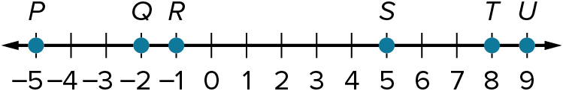

Find the coordinate of point G such that the ratio of $\overline{RG}$ to $\overline{GU}$ is 3:2.

Find the coordinate of point E that is $\frac{1}{3}$ of the distance from R to T.

Find the coordinate of point O such that the ratio of $\overline{QO}$ to $\overline{OT}$ is 1:4.

1-6 Opener – Locating Points on Coordinate Plane
Name: _________________________________ Date:________ Period:________
- Find the coordinates of point X on the coordinate plane for each situation.
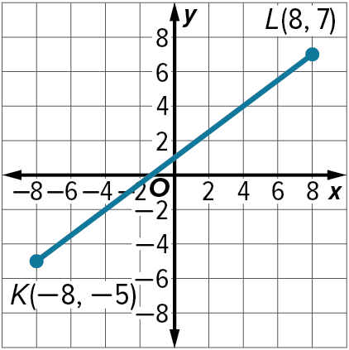
Point X on $\overline{KL}$ is $\frac{1}{3}$ of the distance from K to L.

- Use the figure to answer the questions:
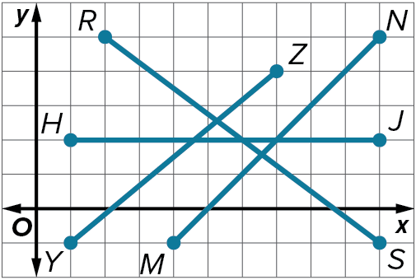
Find point Q on$\overline{ YZ}$ such that the ratio of $\overline{YQ}$ to $\overline{QZ}$ is 1:4.

Find point F on $\overline{HJ}$ such that the ratio of $\overline{HF}$ to $\overline{FJ}$ is 2:3.

1-6 Exit Slip – Locating Points on Coordinate Plane
Name: _________________________________ Date:________ Period:________
- Find the coordinates of point X on the coordinate plane for each situation.
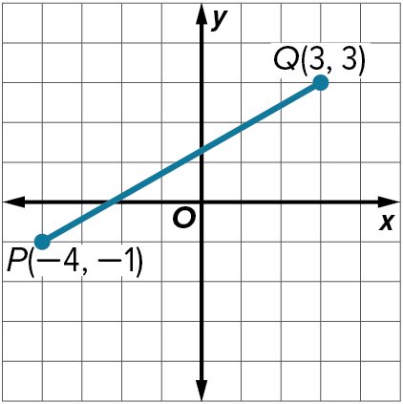
Point X on $\overline{PQ}$ is $\frac{1}{5}$ of the distance from P to Q.

- Use the figure to answer the questions:
Find point A on $\overline{TU}$ that is $\frac{2}{3}$ of the distance from T to U.

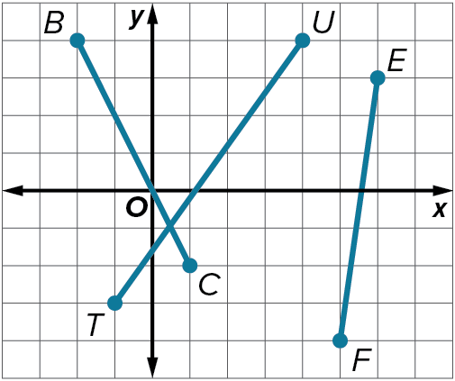
Find point M on $\overline{FE}$ that is $\frac{1}{4}$ of the distance from F to E.

1-7 Opener – Midpoints and Bisectors
Name: _________________________________ Date:________ Period:________
- Find the coordinates of the midpoint of a segment with the given endpoints.
$(5, 24), (–1, 10)$ $(7, 7), (7, 3)$

- Find the coordinates of the missing endpoint if B is the midpoint of $\overline{AC}$.
$A(2, 1), B(10, 4)$

- Suppose M is the midpoint of $\overline{JK}$. Find each missing measure.
$JM = y + 4, MK = 2y + 2$, $JK =$ ?

1-7 Exit Slip – Midpoints and Bisectors
Name: _________________________________ Date:________ Period:________
- Find the coordinates of the midpoint of a segment with the given endpoints.
$(4, 4), (130, 110)$ $(1, 7), (3, 29)$

- Find the coordinates of the missing endpoint if B is the midpoint of $\overline{AC}$.
$B(18, 7), C(32, 2)$

- Suppose M is the midpoint of $\overline{JK}$. Find each missing measure.
$MK = 5x + 5, JK = 48, x = ?$

