7-1 Opener - Angles of Polygons
Name: _________________________________ Date:________ Period:________
- Find the measure of each interior angle.

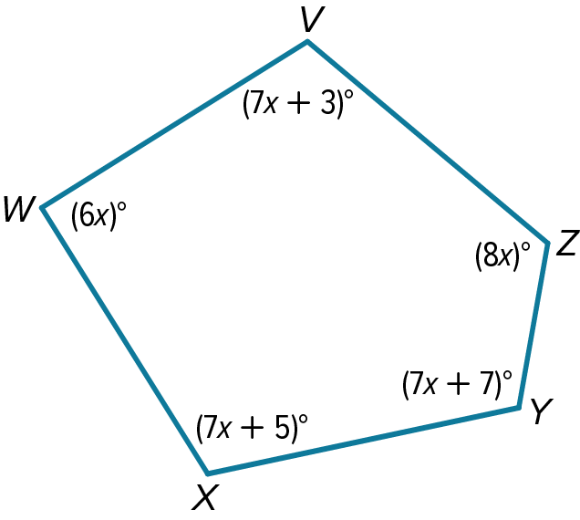

- The measure of an interior angle of a regular polygon is given.
Find the number of sides in the polygon.

162°

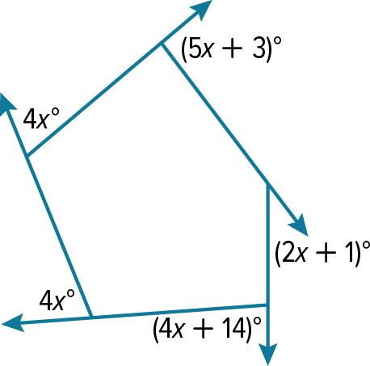
- Find the value of x in each diagram.

7-1 Exit Slip - Angles of Polygons
Name: _________________________________ Date:________ Period:________
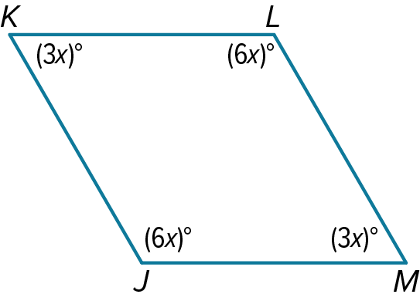
- Find the measure of each interior angle.

- The measure of an interior angle of a regular polygon is given.
Find the number of sides in the polygon.

90°

- Find the value of x in each diagram.

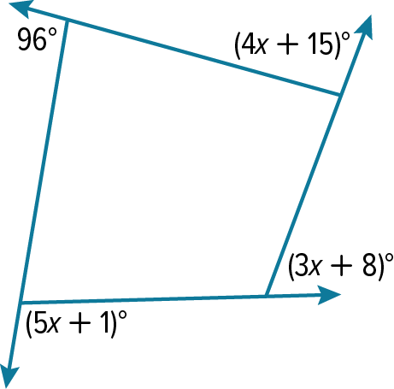

7-2 Opener – Parallelograms
Name: _________________________________ Date:________ Period:________
- Use ▱ABCD to find each measure.
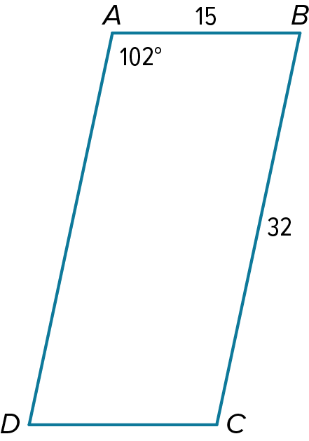
m∠C

DC

- Find the value of the variable.
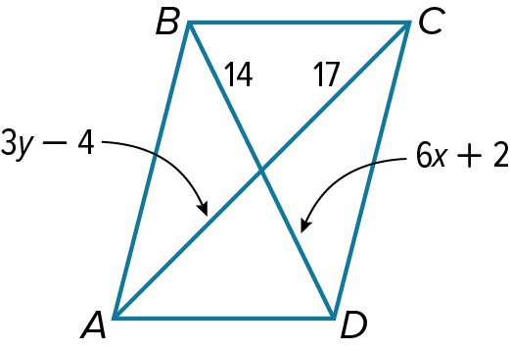
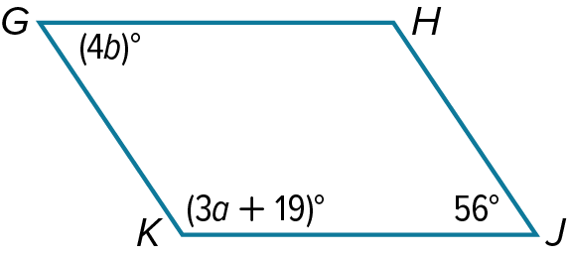

7-2 Exit Slip – Parallelograms
Name: _________________________________ Date:________ Period:________
- Use ▱ABCD to find each measure.
m∠D

AD

- Find the value of the variable in each parallelogram.
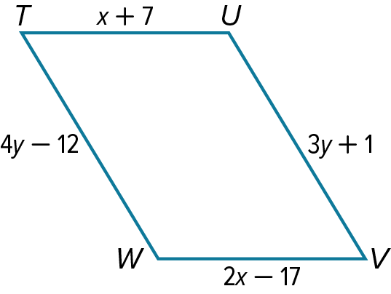
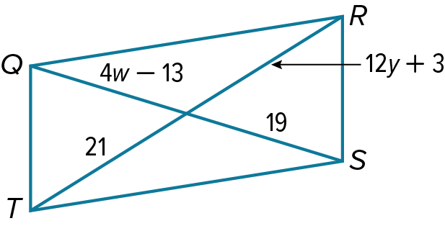

7-3 Opener – Tests for Parallelograms
Name: _________________________________ Date:________ Period:________
- Determine whether each quadrilateral is a parallelogram. State your reasoning.
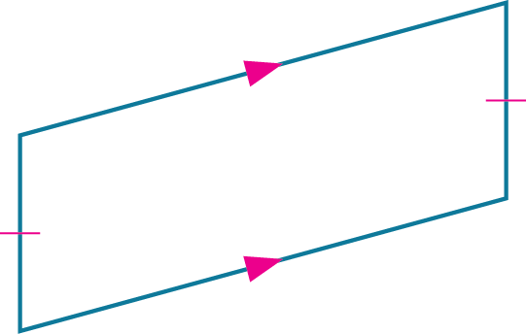
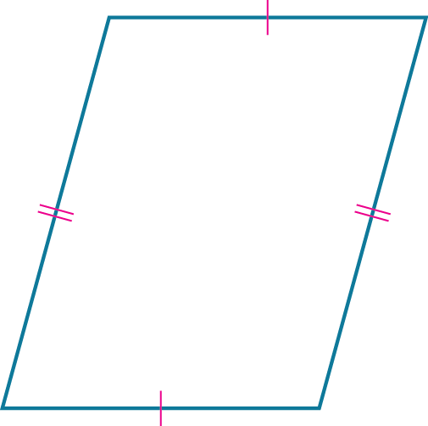

- Determine if the quadrilateral is a parallelogram.
W(5, 6), X(6, 3), Y(3, 0), Z(2, 3); Midpoint Formula

- Find the value of a and b.
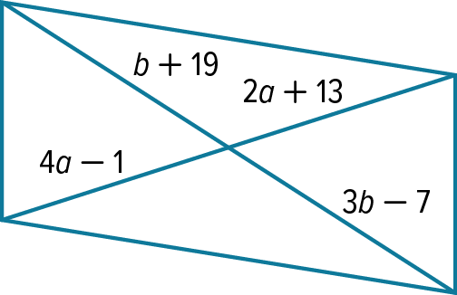

7-3 Exit Slip – Tests for Parallelograms
Name: _________________________________ Date:________ Period:________
- Determine whether each quadrilateral is a parallelogram. State your reasoning.
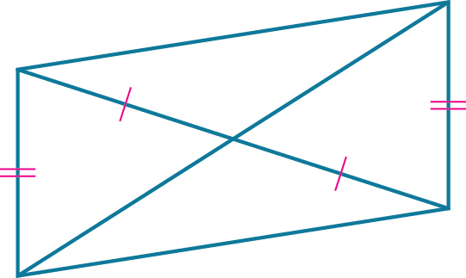
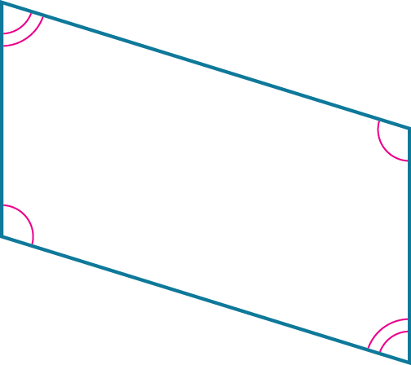

- Determine if the quadrilateral is a parallelogram.
P(–2, 4), Q(4, 5), R(4, 2), S(–2, 0); Slope Formula

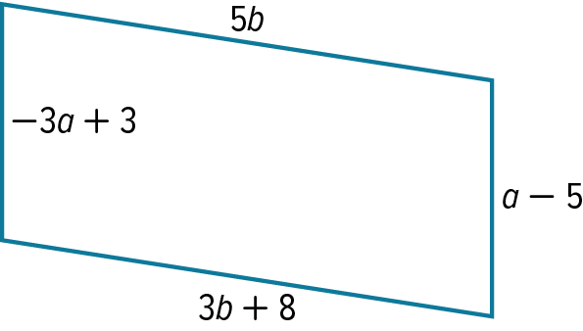

- Find the value of a and b.

7-4 Opener – Rectangles
Name: _________________________________ Date:________ Period:________
- Quadrilateral ABCD is a rectangle. Use the given information to find each measure.
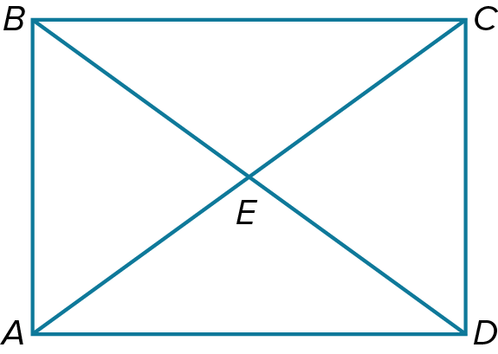
If BD = 12, find ED.

If m∠ABD=47°, find m∠CDB.

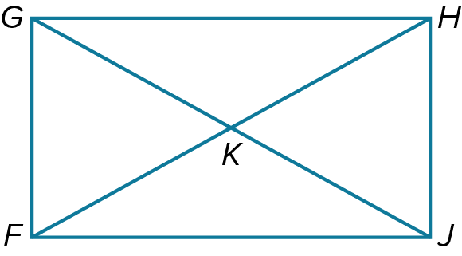
- Write a two-column proof.
Given: FGHJ is a rectangle.
Prove: ∆GKF≅∆JKH

7-4 Exit Slip – Rectangles
Name: _________________________________ Date:________ Period:________
- Quadrilateral ABCD is a rectangle. Use the given information to find each measure.
If m∠BEA=35°, find m∠BAE..

If BA = 3x + 1 and CD = 5x – 3, find BA.

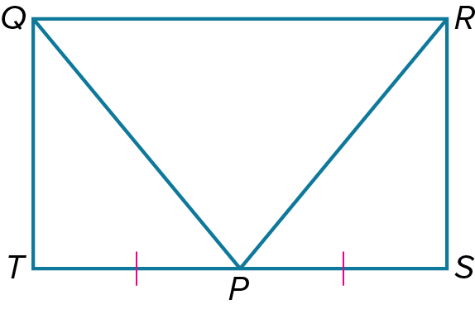
- Write a two-column proof.
Given: QRST is a rectangle; SP≅PT
Prove: RP≅QP

7-5 Opener – Rhombi and Squares
Name: _________________________________ Date:________ Period:________
- Quadrilateral ZYXW is a rhombus. Find each value or measure.
If $m∠ZYW= 37$°, find $m∠YWX.$

If $YV = 7$, find VW.
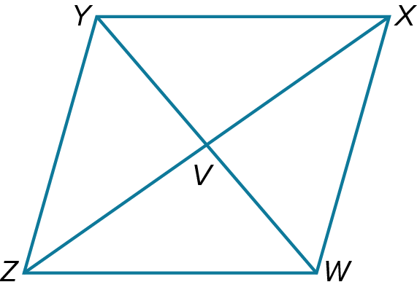

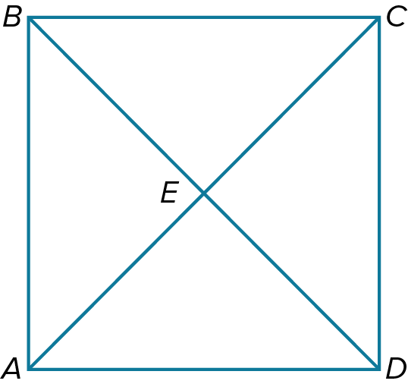
- ABCD is a square.
If $BD=22$, find AE.

7-5 Exit Slip – Rhombi and Squares
Name: _________________________________ Date:________ Period:________
- Quadrilateral ZYXW is a rhombus. Find each value or measure.
If $m∠VWZ= 39°,$ find $m∠VZW$

If YW = 6 and XW = 5, find VX.

- PQRS is a square.
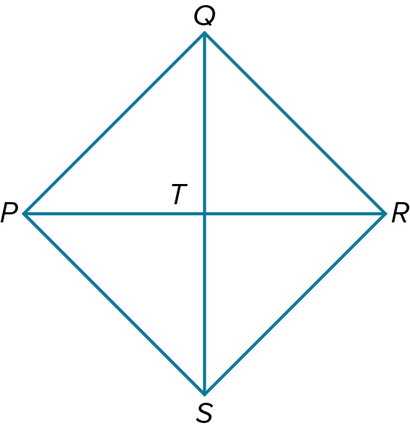
If $QS=17$, find QT.

  - Opener – Trapezoids and Kites
Name: _________________________________ Date:________ Period:________
- Find each measure
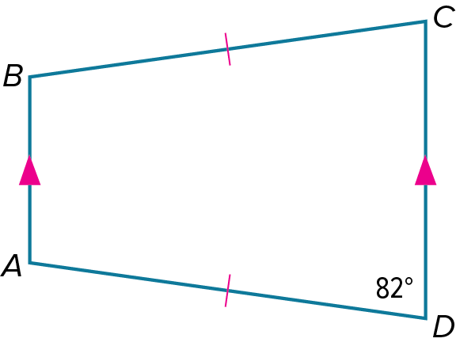

m∠A

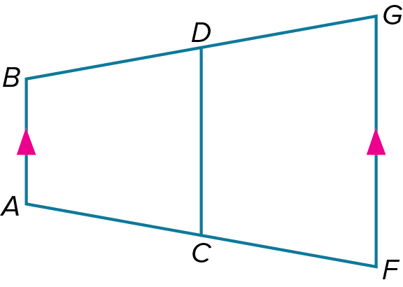

- CD is the midsegment of trapezoid ABGF.

If FG = 22 and CD = 13, find AB.
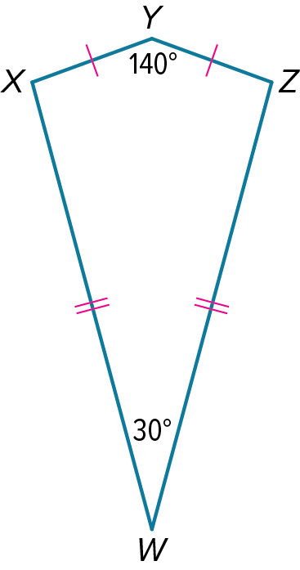

- Find each measure in the kite.

7-6 Exit Slip – Trapezoids and Kites
Name: _________________________________ Date:________ Period:________
- Find each measure
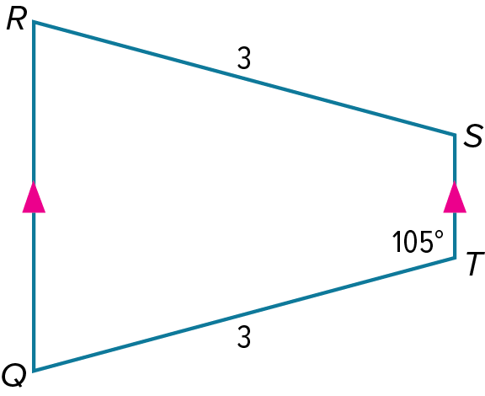

m∠R

- CD is the midsegment of trapezoid ABGF.

If BA = 17 and DC = 32, find CD.

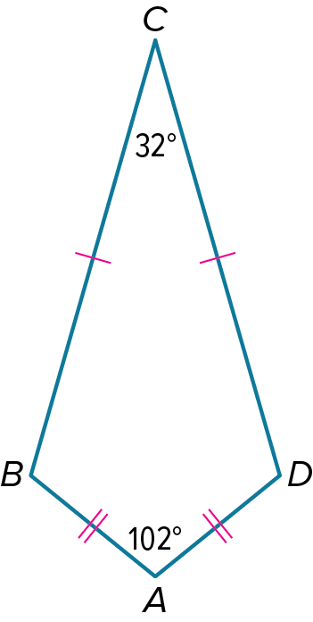

- Find each measure in the kite.

