**Northwest Pennsylvania Collegiate Academy**

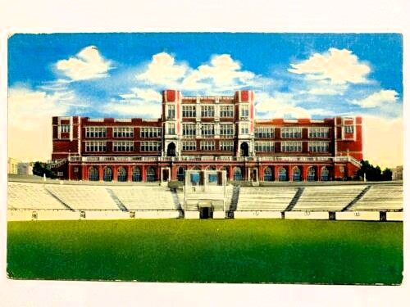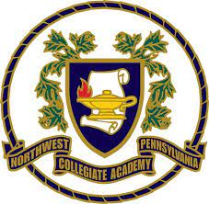**Bell Schedule**

|  |  |  |
| --- | --- | --- |
| **HOMEROOM** | | 8:40-8:55 |
| **PERIOD 1** | | 9:00-10:25 |
| **PERIOD 2** | | 10:30-11:55 |
| **PERIOD 3** | | 12:00-2:10 |
| **FIRST LUNCH** | LUNCH | 12:00-12:30 |
| CLASS | 12:35-2:10 |
| **SECOND LUNCH** | CLASS | 12:00-12:45 |
| LUNCH | 12:50-1:20 |
| CLASS | 1:25-2:10 |
| **THIRD LUNCH** | CLASS | 12:00-1:35 |
| LUNCH | 1:40-2:10 |
| **PERIOD 4** | | 2:15–3:40 |

Pride - Honor - Respect