8-1 Opener - Dilations
Name: _________________________________ Date:________ Period:________
- Determine whether the dilation from the figure on the left to the figure on the right is an enlargement or a reduction. Then find the scale factor of the dilation.
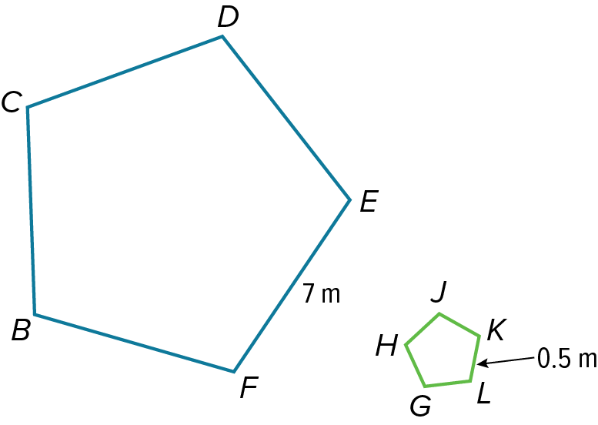
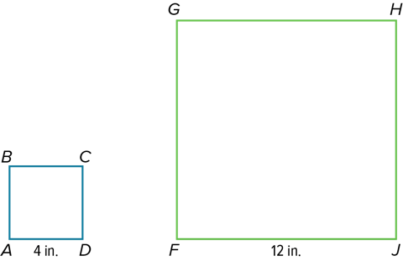

- For each set of triangle vertices, find the coordinates of the vertices of the image after a dilation of the triangle by the given scale factor.
A(–4, 4), B(4, 4), C(4, –2), k = 0.5

8-1 Exit Slip - Dilations
Name: _________________________________ Date:________ Period:________
- Determine whether the dilation from the figure on the left to the figure on the right is an enlargement or a reduction. Then find the scale factor of the dilation.
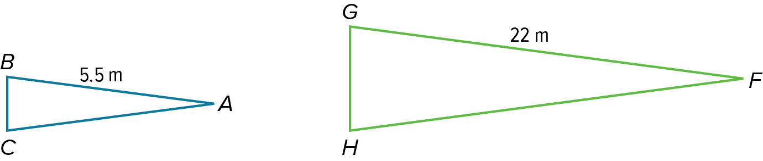
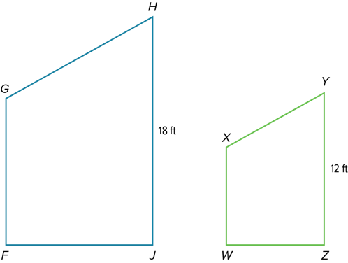

- For each set of triangle vertices, find the coordinates of the vertices of the image after a dilation of the triangle by the given scale factor.
T(–1, –3), U(–4, –4), V(–3, –2), k = 2

8-2 Opener – Similar Polygons
Name: _________________________________ Date:________ Period:________
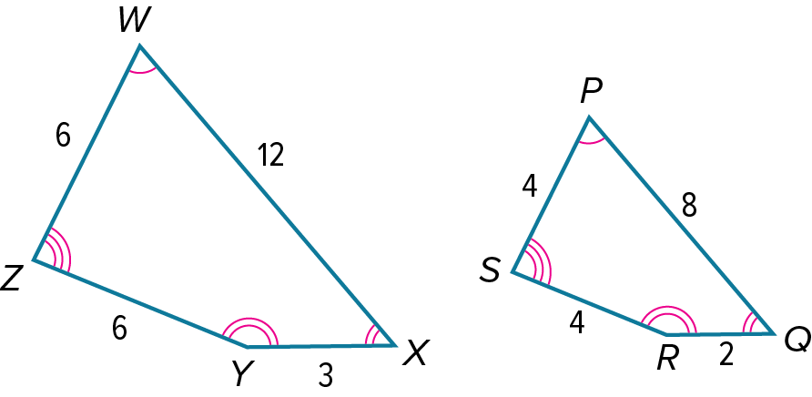
- Determine whether each pair of figures is similar. If so, find the scale factor. Explain your reasoning.
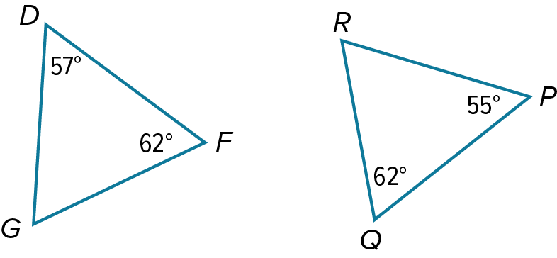

- Each pair of polygons is similar. Find the value of x.
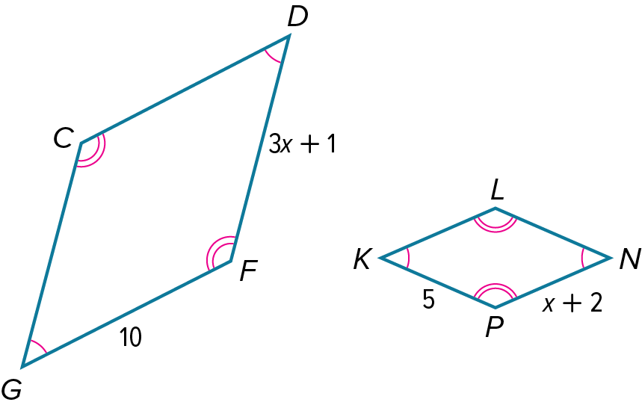
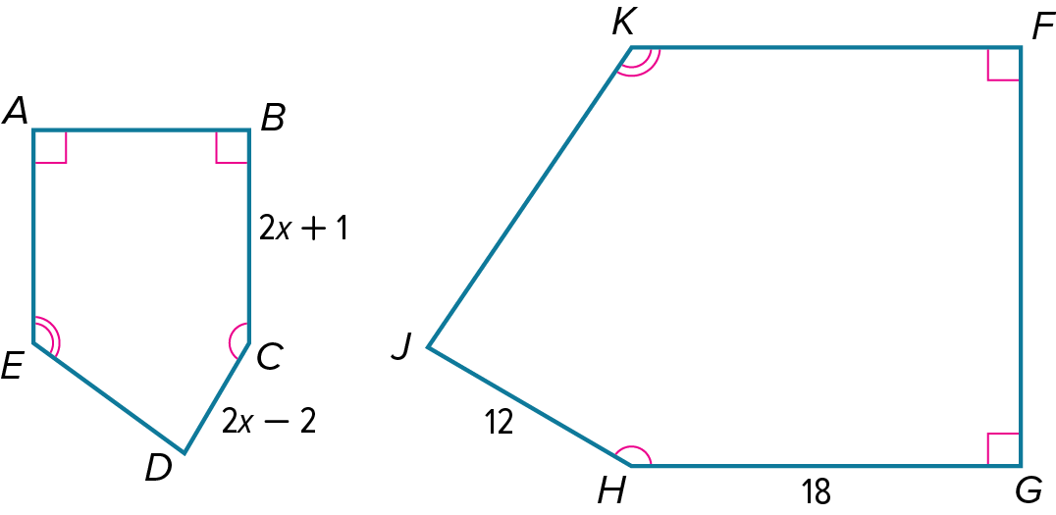

8-2 Exit Slip – Similar Polygons
Name: _________________________________ Date:________ Period:________
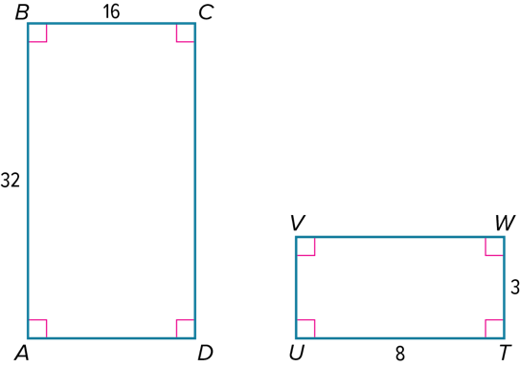
- Determine whether each pair of figures is similar. If so, find the scale factor. Explain your reasoning.
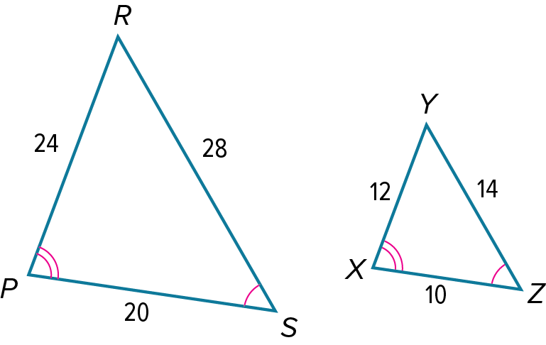

- Each pair of polygons is similar. Find the value of x.

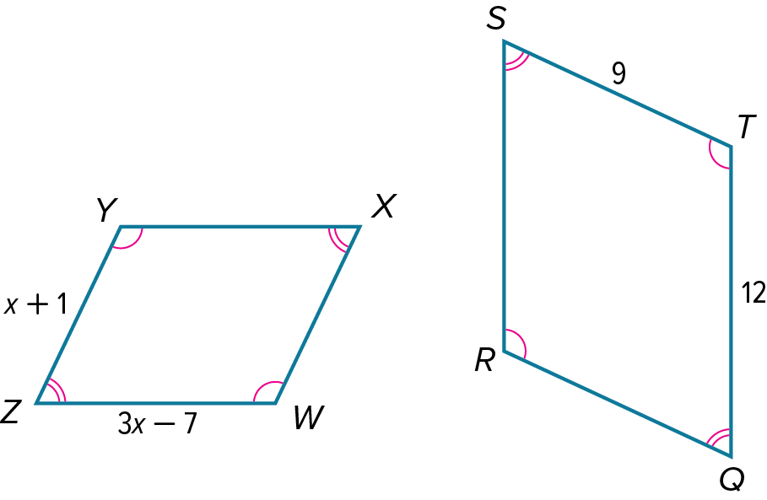
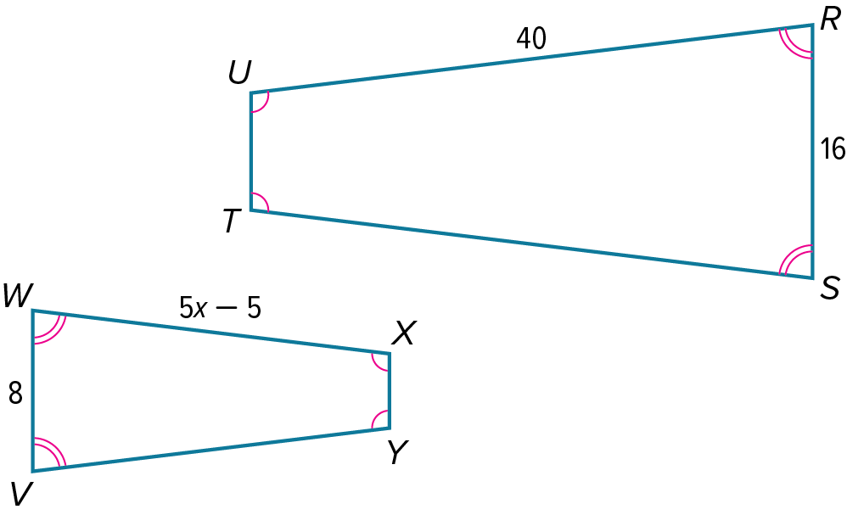

8-3 Opener – Similar Triangles: AA Similarity
Name: _________________________________ Date:________ Period:________
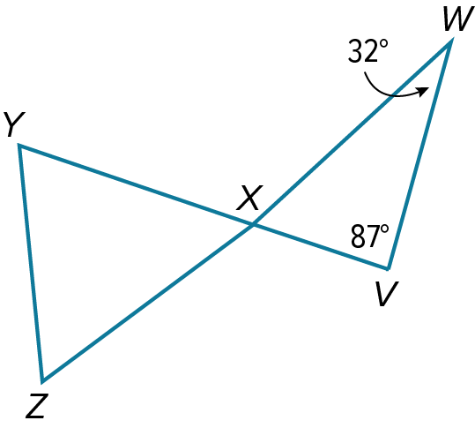
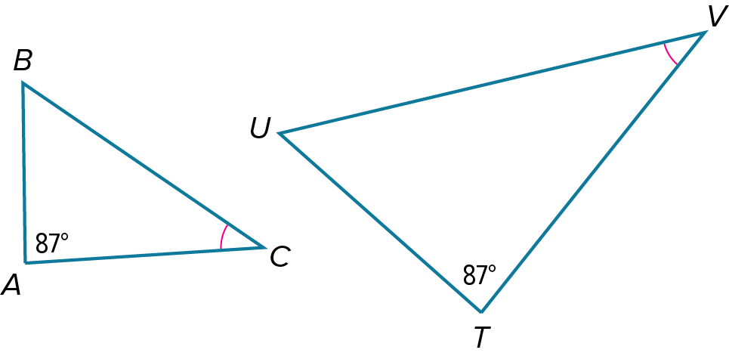
- Determine whether each pair of triangles is similar. Explain your reasoning.

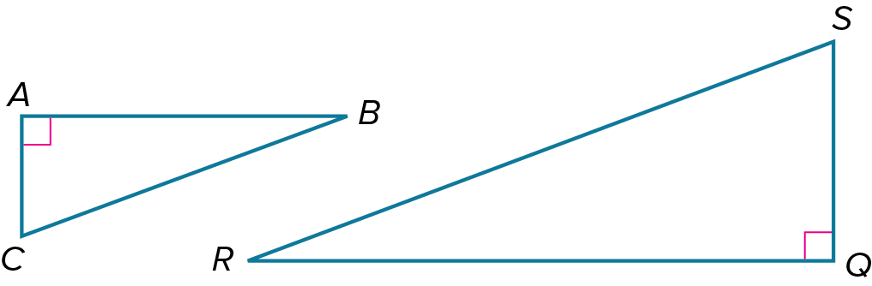
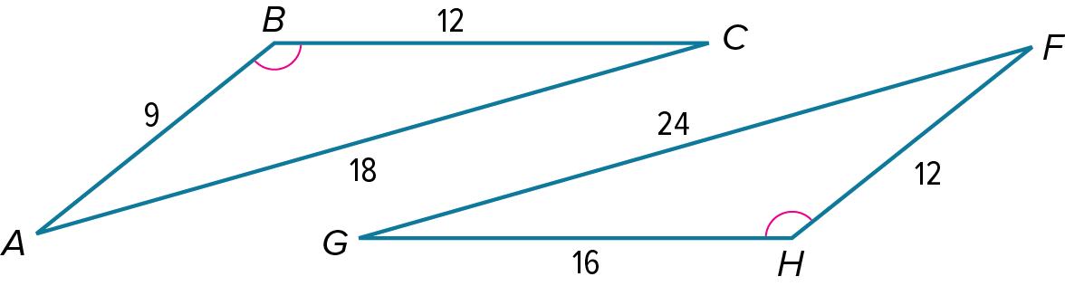

8-3 Exit Slip – Similar Triangles: AA Similarity
Name: _________________________________ Date:________ Period:________
- Determine whether each pair of triangles is similar. Explain your reasoning.

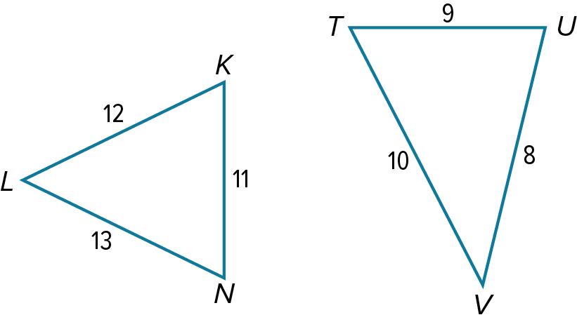
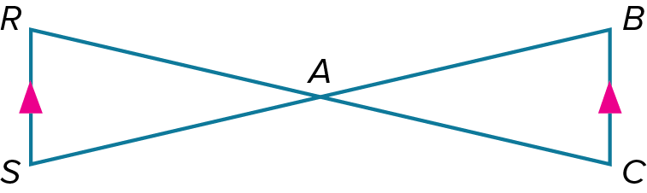

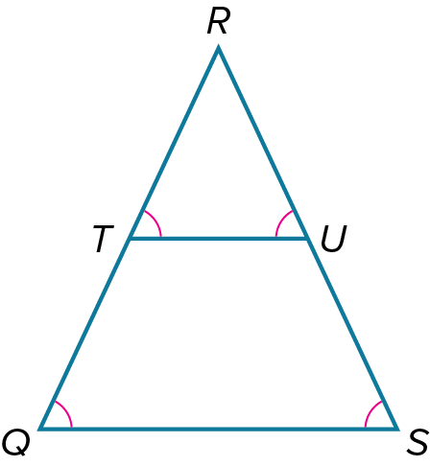
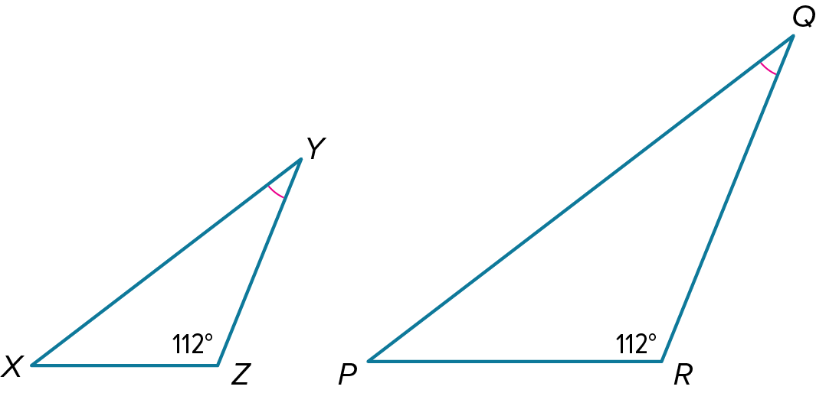

8-4 Opener – Similar Triangles: SSS and SAS Similarity
Name: _________________________________ Date:________ Period:________
- Determine whether each pair of triangles is similar. Explain your reasoning.
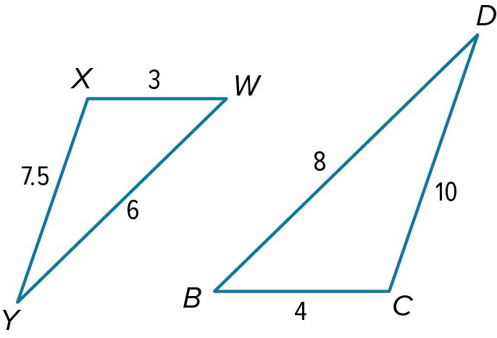
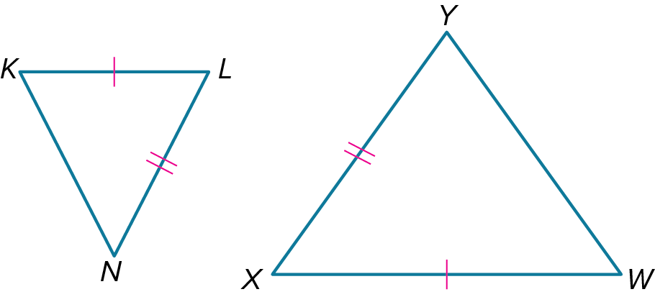

- Identify the similar triangles. Then find the value of x. Round your answer to the nearest tenth, if necessary.
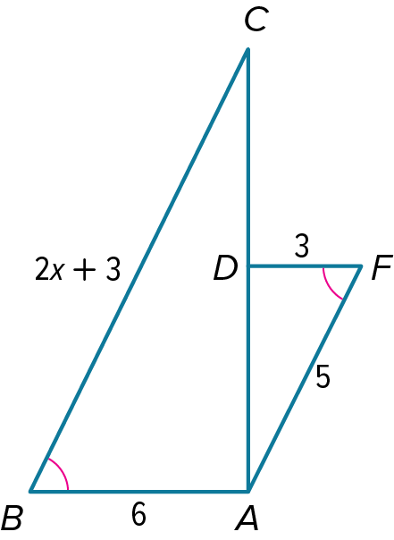
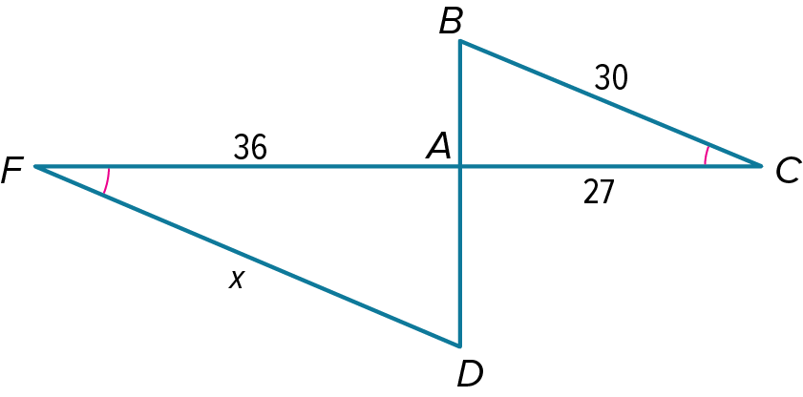

8-4 Exit Slip – Similar Triangles: SSS and SAS Similarity
Name: _________________________________ Date:________ Period:________
- Determine whether each pair of triangles is similar. Explain your reasoning.
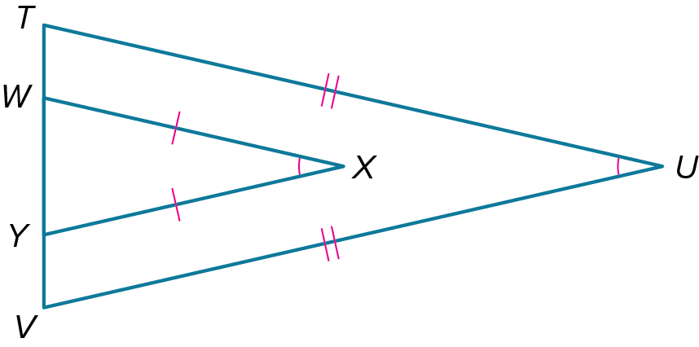
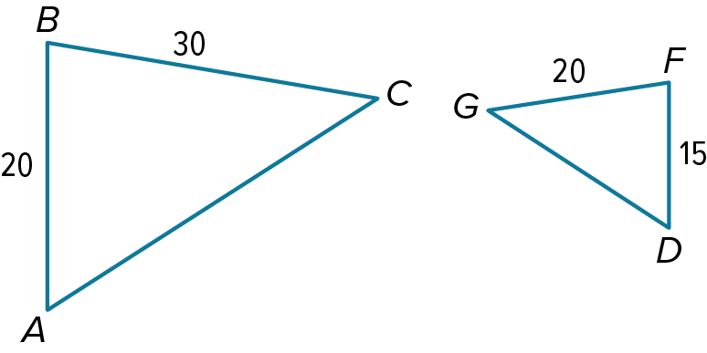

- Identify the similar triangles. Then find the value of x. Round your answer to the nearest tenth, if necessary.
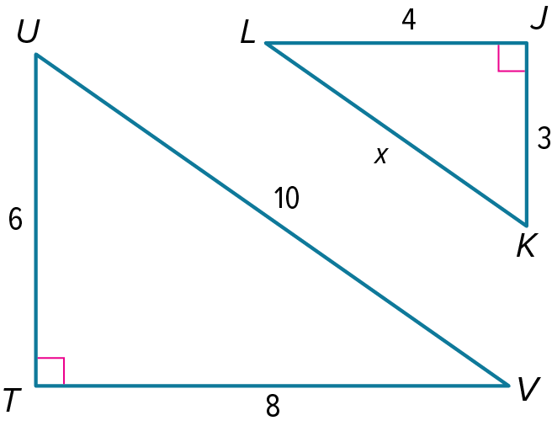
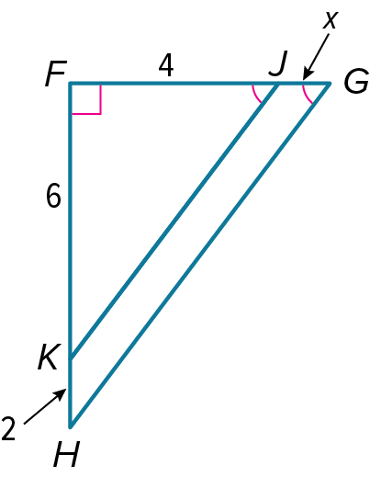

8-5 Opener – Triangle Proportionality
Name: _________________________________ Date:________ Period:________
- Use the figure to answer the question.
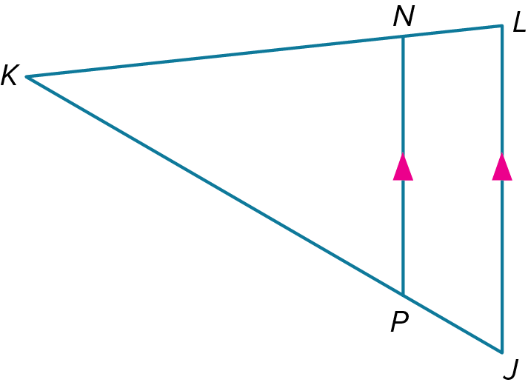
If NL = 3, KL = 12, and KJ = 16, find KP.

- DF, FG, and GD are midsegments of ∆ABC. Find the value of x.

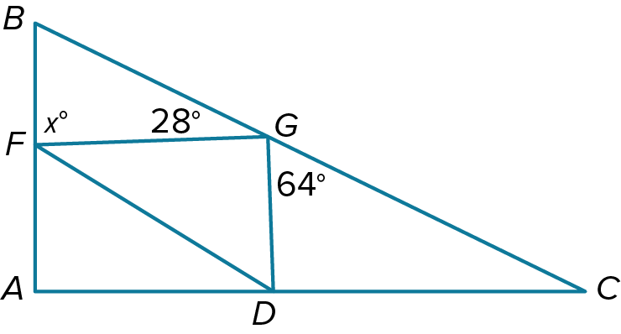
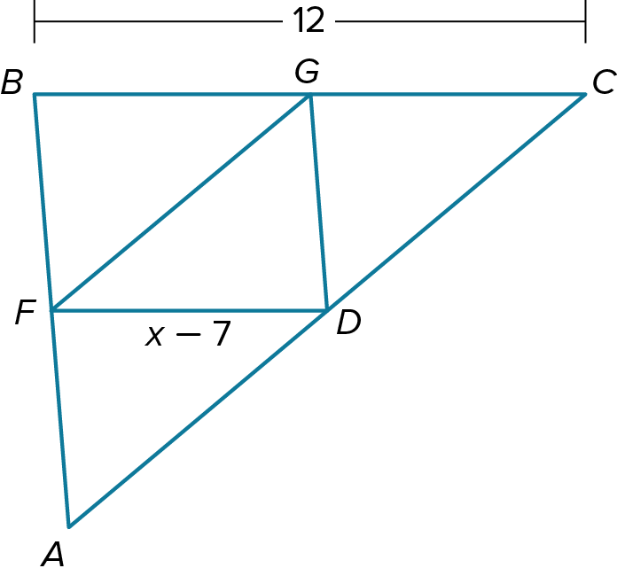

8-5 Exit Slip – Triangle Proportionality
Name: _________________________________ Date:________ Period:________
- Use the figure to answer the question.
If KP = 24, PJ = 8, and NL = 7, find KL.

- DF, FG, and GD are midsegments of ∆ABC. Find the value of x.

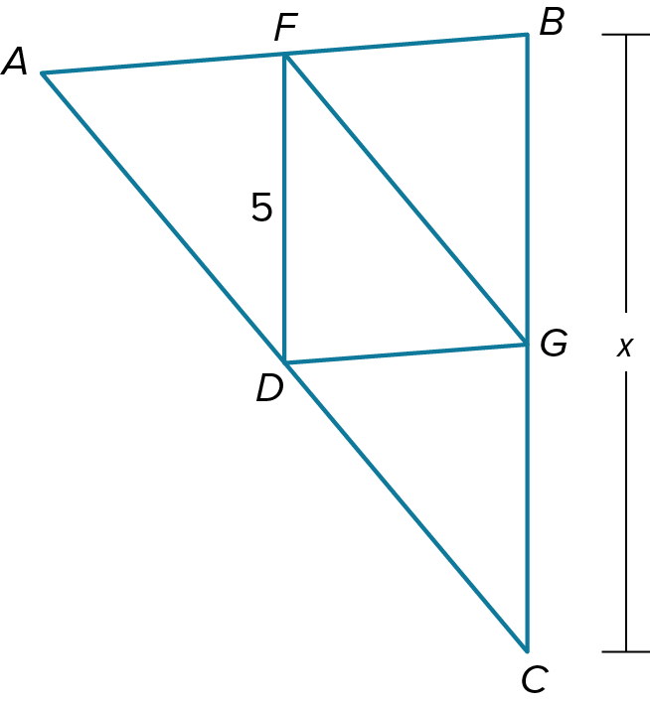
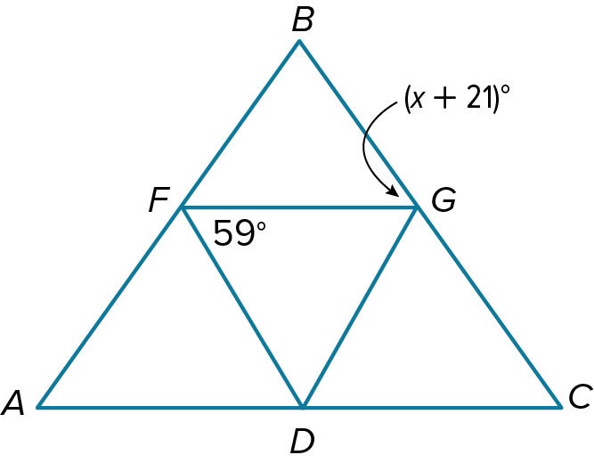

8-6 Opener – Parts of Similar Triangles
Name: _________________________________ Date:________ Period:________
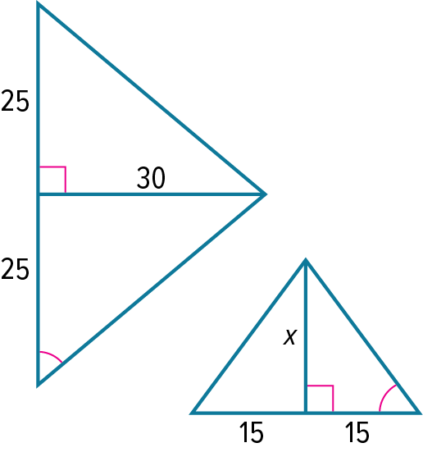
- Each pair of triangles is similar. Find the value of x.

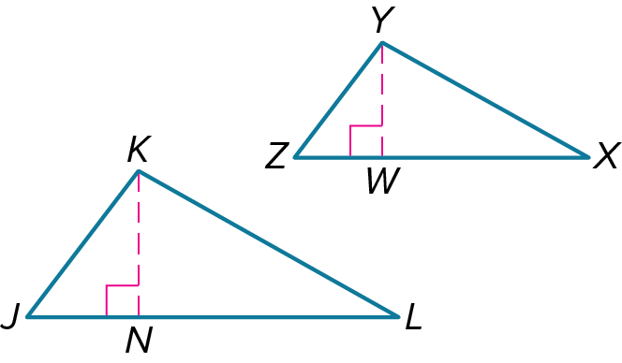
- If ∆JKL~∆ZYX, KN is an altitude of ∆JKL, YW is an altitude of ∆ZYX, JK = 22, KN = 18, and YW = 15, find ZY.

- Find the value of each variable to the nearest tenth.

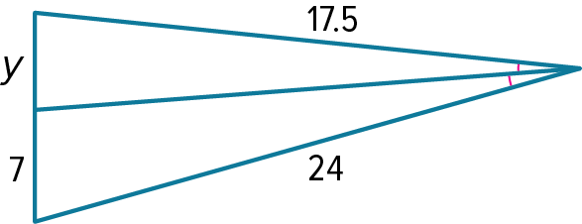

8-6 Exit Slip – Parts of Similar Triangles
Name: _________________________________ Date:________ Period:________
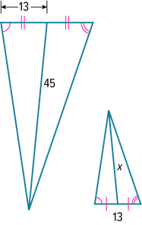
- Each pair of triangles is similar. Find the value of x.

- If ∆ABC~∆FGH, BD is an altitude of ∆ABC, GK is an altitude of ∆FGH, AB = 4, BD = 3, and FG = 6, find GK.
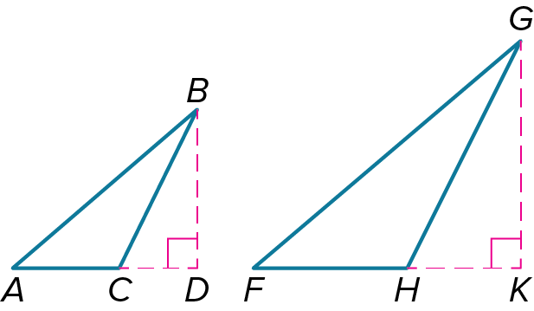

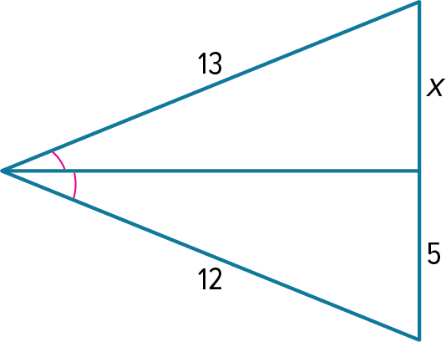
- Find the value of each variable to the nearest tenth.

