5-1 Opener - Angles of Triangles

Name: _________________________________ Date:________ Period:________

Find the measure of each numbered angle.

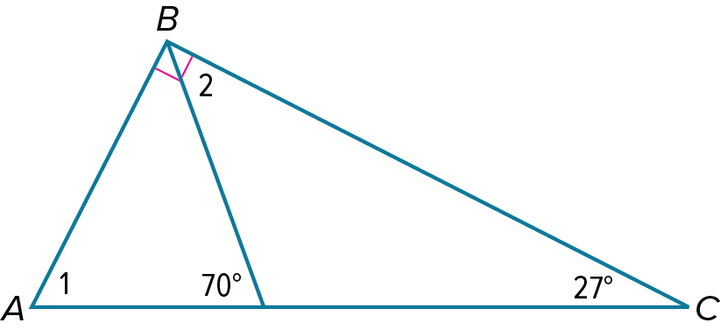

Find*m*∠*ACB.*

1. Find each measure in triangle .

5-1 Exit Slip - Angles of Triangles

Name: _________________________________ Date:________ Period:________

1. Find the measure of each numbered angle.

Find *m*∠*FGH*

1. Find each measure in rectangle ABCD

5-2 Opener – Congruent Triangles

Name: _________________________________ Date:________ Period:________

Show that the polygons are congruent by identifying all congruent corresponding parts. Then, write the congruence statement.

In the diagram, polygon polygon .

Find the value of

Find .

Find the value of .

5-2 Exit Slip – Congruent Triangles

Name: _________________________________ Date:________ Period:________

Show that the polygons are congruent by identifying all congruent corresponding parts. Then, write the congruence statement.

In the diagram, .

Find the value of .

Find .

Find the value of .

5-3 Opener – Proving Triangles Congruent: SSS and SAS

Name: _________________________________ Date:________ Period:________

Write the specified proof using a two-column proof.

1. A blue and pink triangle with a black background

   Description automatically generated

**Given:** ,

**Prove:** ∆ABC≅∆DCB

**Given:** JK≅BC, KL≅CD, LJ≅DB

**Prove:** ∆JKL≅∆BCD

5-3 Exit Slip – Proving Triangles Congruent: SSS and SAS

Name: _________________________________ Date:________ Period:________

Write the specified proof using a two-column proof.

1. A blue and pink triangle with pink and blue lines

   Description automatically generated

**Given:** JK≅KL**,** *M* is the midpoint ofJL.

**Prove:** ∆JKM≅LKM

1. A blue line on a black background

   Description automatically generated

**Given:** QR≅RS and ∠QRT≅∠SRT

**Prove:** ∆QRT≅∆SRT

5-4 Opener – Proving Triangles Congruent: ASA and AAS

Name: _________________________________ Date:________ Period:________

Write the specified proof using a two-column proof.

1. A blue and pink bar

   Description automatically generated

**Given:** , ,

and are right angles.

**Prove:**

**Given:** bisects  , ,

<X≅∠VYU

**Prove:** ∆UVY≅∆YWX

5-4 Exit Slip – Proving Triangles Congruent: ASA and AAS

Name: _________________________________ Date:________ Period:________

Write the specified proof using a two-column proof.



**Given:** , is the midpoint of .

**Prove:**

**Given:**

**Prove:**

5-5 Opener – Proving Right Triangles Congruent

Name: _________________________________ Date:________ Period:________

**INTERIOR ROOF STRUCTURE** Typical interior roof structures use beams and braces that form specific geometric patterns. Write a two-column proof to show that the triangles formed by the diagonal support posts are congruent.

**Given:** *B* is the midpoint of AE; CB≅DB;

∠CAB and ∠DEB are right angles.

**

**TOAST**  Two pieces of toast will make a perfect match if the triangles shown are congruent. Write a two-column proof to show that the illustrated triangles are congruent.

**Given:** PR≅TV:PQ≅TU:∠Q and ∠U are right angles.

**Prove:** ∆PQR≅∆TUV

5-5 Exit Slip – Proving Right Triangles Congruent

Name: _________________________________ Date:________ Period:________

**SAILBOAT**  Sailboats have triangular-shaped sails to catch the wind and push the boats. Write a two-column proof to show that the illustrated triangles are congruent.

**Given:**  ∠S and ∠Z are right angles, ∠RQS≅∠YXZ: QR≅XY

**Prove:** ∆RQS≅∆YXZ

**CLASSIC ARCHITECTURE**  Engineers began using sloped roofs in classic architecture thousands of years ago. Write a two-column proof to show that the illustrated triangles are congruent.

**Given:** WYX and WYZ are right angles, XY≅ZY

**Prove:** ∆WYX≅∆WYZ

* 1. Opener – Isosceles and Equilateral Triangles

Name: _________________________________ Date:________ Period:________

Find the value of .

**BILLIARDS** A billiards ball rack can be modeled by ∆*ABC*. Solve for x and y.

5-6 Exit Slip – Isosceles and Equilateral Triangles

Name: _________________________________ Date:________ Period:________

1. Find the value of x.

**

**PYRAMIDS** A pyramid is made up of four triangular sides. Solve for x and y.

