2-1 Opener - Angles and Congruence

Name: _________________________________ Date:________ Period:________

1. Use the figure to identify angles and parts of angles that satisfy each given condition.

What is another name for ∠2?

What is another name for ∠4?

1. Use the figure to answer the question.

 In the figure, and are opposite rays. bisects .   
If and, find .

1. Find the value of the variable.

2-1 Exit Slip - Angles and Congruence

Name: _________________________________ Date:________ Period:________

1. 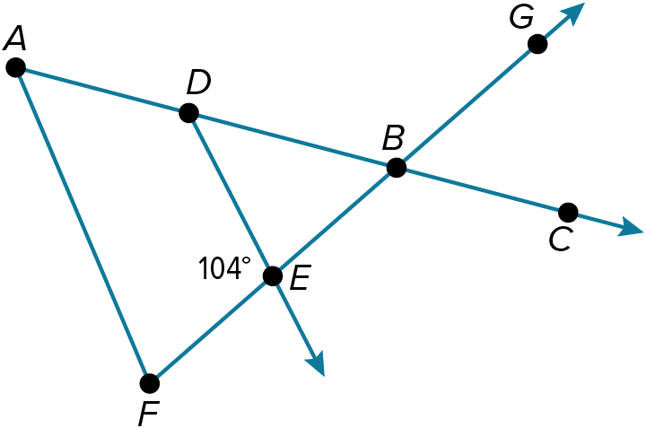Refer to the figure.

Name two adjacent angles.

Name two vertical angles.

Find .

1. Find the value of the variable.

2-2 Opener – Angle Relationships

Name: _________________________________ Date:________ Period:________

Use the figure to answer the questions.

1. The measure of the supplement of an angle is four times the measure of the angle.

Find the measures of the angle and its supplement?

1. Rays and are perpendicular. Point V lies in the interior of .

If and find , , and .

1. Determine whether each statement can be assumed from the given figure. Explain.

∠4 and ∠7 are supplementary.

∠3 and ∠10 are complementary.

∠2 and ∠10 are vertical angles.

2-2 Exit Slip – Angle Relationships

Name: _________________________________ Date:________ Period:________

Use the figure to answer the questions.

1. ∠B and ∠C are supplementary. The measure of ∠B is 83° more than the measure of ∠C. Find the measure of each angle.
2. Determine whether each statement can be assumed from the given figure.

∠7 and ∠9 are vertical angles.

∠4 and ∠5 form a linear pair.

∠1 and ∠2 form a linear pair.

2-3 Opener – 2 Dimensional Figures

Name: _________________________________ Date:________ Period:________

Find the area, circumference, and perimeter of each figure or description.

1)

2)

3)

4)

2-3 Exit Slip – 2 Dimensional Figures

Name: _________________________________ Date:________ Period:________

Find the area, circumference, and perimeter of each figure or description.

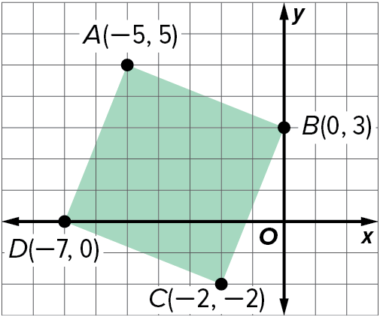

1)

2)

3)

4)

2-4 Opener – Transformations in the Plane

Name: _________________________________ Date:________ Period:________

1) Identify the type of rigid motion shown as a reflection, translation, or rotation.

1. Triangle JKL has coordinates J(2, –5), K(–1, –3), and L(–4, 5). Determine the coordinates of the vertices of the image after each transformation.

translation along the vector

rotation about the origin

2-4 Opener – Transformations in the Plane

Name: _________________________________ Date:________ Period:________

1) Identify the type of rigid motion shown as a reflection, translation, or rotation.

1. Triangle JKL has coordinates J(–1, 5), K(1, 2), and L(–3, –1). Determine the coordinates of the vertices of the image after each transformation.

translation along the vector 〈5, –4〉

rotation 90° counterclockwise about the origin

2-5 Opener – 3 Dimensional Figures

Name: _________________________________ Date:________ Period:________

1. A blue pyramid with a dotted line

   Description automatically generatedDetermine whether each solid is a polyhedron. Then identify the solid. If it is a polyhedron, name the bases, faces, edges, and vertices.

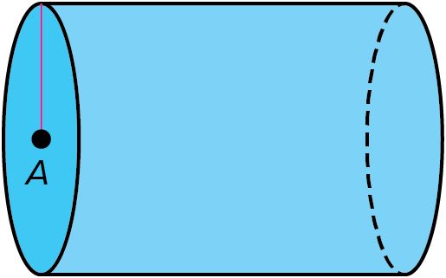

1. Find the surface area and volume of the following figures.

2-5 Exit Slip – 3 Dimensional Figures

Name: _________________________________ Date:________ Period:________

1. Determine whether each solid is a polyhedron. Then identify the solid. If it is a polyhedron, name the bases, faces, edges, and vertices

1. A blue cylinder with a black line

   Description automatically generatedFind the surface area and volume of the following figures.

2-6 Opener – Represent 3D in 2D

Name: _________________________________ Date:________ Period:________

1. Make an orthographic drawing of the figure.

1. Make a model of the solid that is represented by the net. Then identify the solid and find its surface area.

2-6 Exit Slip – Represent 3D in 2D

Name: _________________________________ Date:________ Period:________

1. Make an orthographic drawing of the figure.

1. Make a model of the solid that is represented by the net. Then identify the solid and find its surface area.

2-7 Opener – Precision and Accuracy

Name: _________________________________ Date:________ Period:________

**GOLF BALLS** A national sports equipment retailer is selling golf balls in bags of 50 golf balls per bag. A consumer advocate group checks 10 random bags, and the actual count for these is 50, 50, 50, 50, 50, 50, 50, 50, 50, and 50 balls per bag. How accurate and precise is the retailer’s advertisement? Explain your reasoning.

**ROPE** The local hardware store sells nylon rope in packages labeled as containing 100 feet of rope. The rope in one package measured 101.5 feet. What is the approximate error?

2-7 Exit Slip – Precision and Accuracy

Name: _________________________________ Date:________ Period:________

**COFFEE**  A coffee maker manufacturer claims that the customer will get 48 six-ounce cups of coffee from a one-pound bag of coffee. A survey of 7 customers reveals that actual cup counts by the customers of 49, 50, 53, 47, 45, 42, and 53. Is the manufacturer’s claim accurate? Is the manufacturer’s claim precise? Explain your reasoning.

**STRING** The package for a ball of string states that the length of the string is 400 yards. The actual measured length is 403 yards. What is the approximate error?

2-8 Opener – Representing Measurements

Name: _________________________________ Date:________ Period:________

Determine the number of significant digits in each measurement.

978.56 1000

**LAB MEASUREMENTS** Dr. Metser asked his physical science class to weigh a sample of lead which was to be used in an experiment. He asked the students to record their measurements to 3 significant digits. Which student did as he instructed?

|  |  |
| --- | --- |
| **Student** | **Weight (g)** |
| Althea | 2.25 |
| Berto | 2.258 |
| Rebecca | 2.2 |

2-8 Exit Slip – Representing Measurements

Name: _________________________________ Date:________ Period:________

Determine the number of significant digits in each measurement.

4.68 0.0602

**FREEZER** A food freezer has interior dimensions of 2.58 feet by 5.1 feet by 2.14 feet. Find the storage volume of the freezer. Round your answer to the correct number of significant figures.