Submitting Assignments in Schoology

Step 1: Please select and click on the posted assignment.

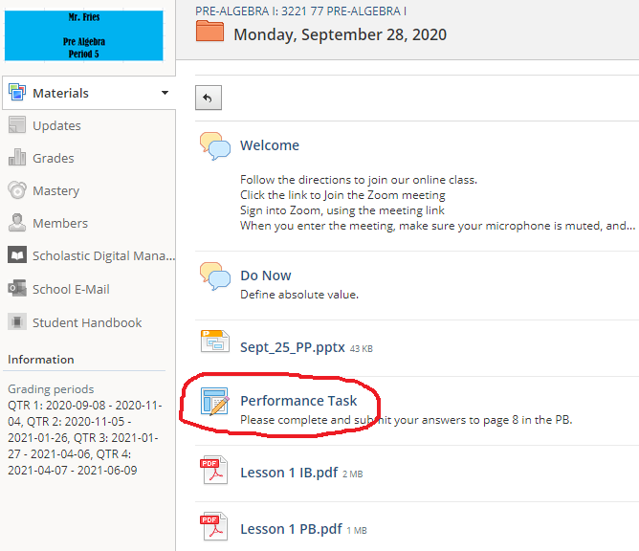

Step 2: Click on the Submit Assignment button.

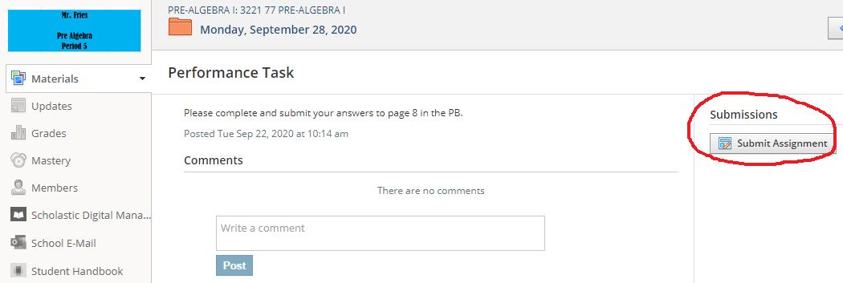

Step 3: Click the Create button.

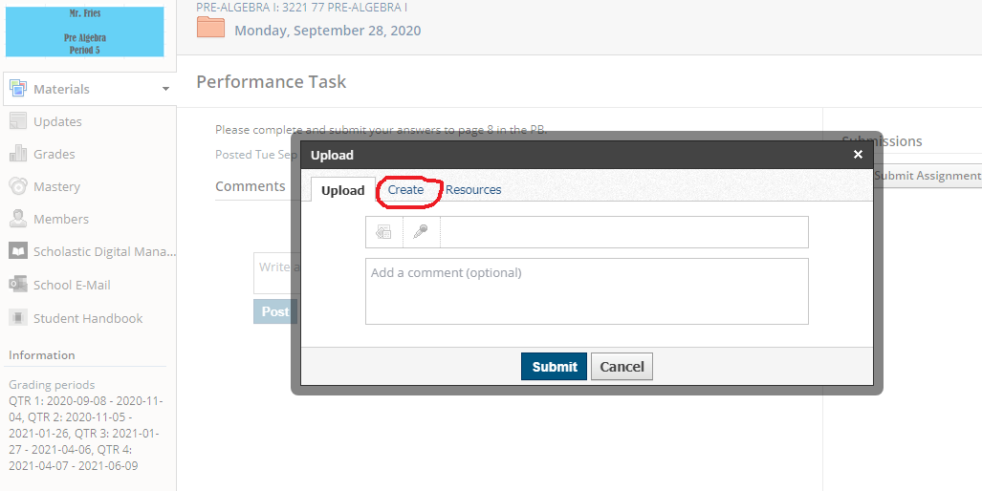

Step 4: Type information/answers into the text box.

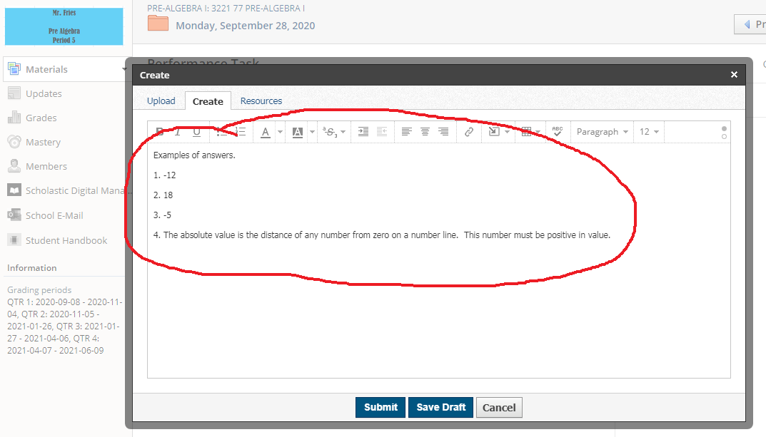

Step 5: Click the Submit button to turn in your assignment.

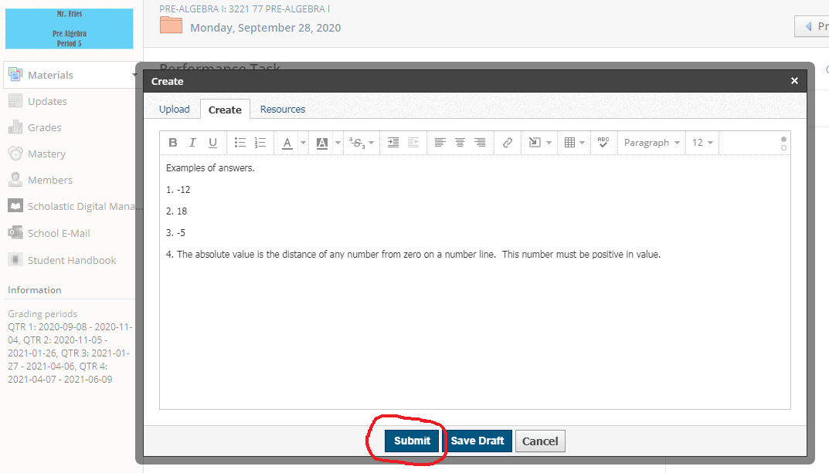

For further assistance, please click the link below to view the Youtube video.

https://www.youtube.com/watch?v=auTLiPL4iYI

