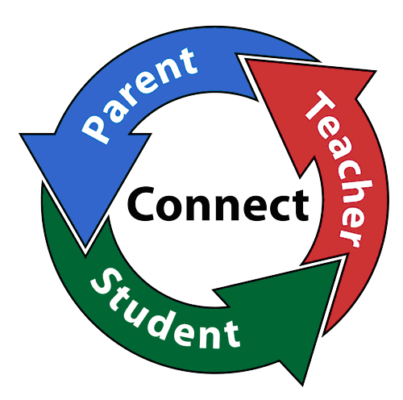
Parent Involvement Survey
Did you find the information presented helpful?

Are you satisfied with the updated Parental Involvement Policy and Compact?

Are there any concepts and/or skills you think our teachers need to better serve you and your children?

Do you have any suggestions that would help us increase our parental involvement activities during the year?

Please provide us with your contact information if you would like to present a topic to our faculty and staff. We value parents as partners!

