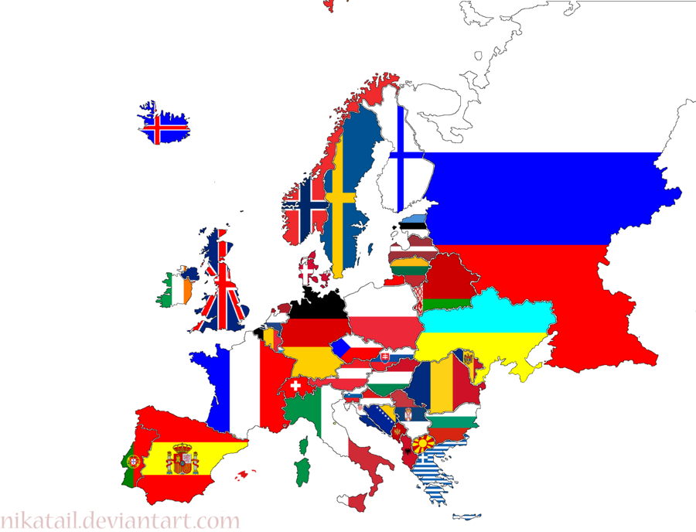
NAME:____________________________________________DATE:___________
CHAPTER 10 SECTION 1 PGS. 273-277 KEY QUESTIONS

DIRECTIONS: Answer all questions in complete sentences! Prove where you found your answer!

- What are the distinctive features of Europe’s geography?

- What geographical feature of Europe influenced the development of different cultures?

- What is an important feature of the Great European Plain?

- What are the average January and July temperatures in southern Europe?

- Why is the Mediterranean coast a popular vacation spot?

- What are some of Europe’s mineral resources?

- What factors make Europe a good place to grow crops?

