bl  blocks | br  bread | cl  clock | cr  crayon | dr  drum
fl  fly | fr  fruit | gl  globe | gr  grapes | pl  plane
pr  prince | sc  scared | scr  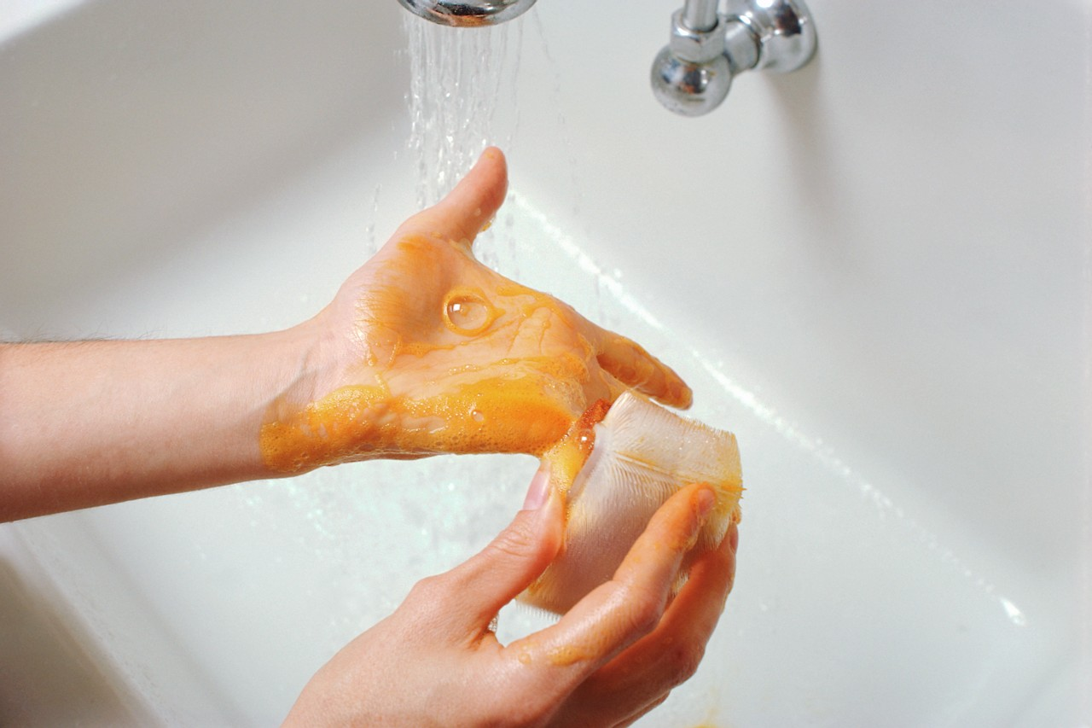  scrub | sk  skate | sl  slide
sm  smile | sn  snail | sp  spoon | spr  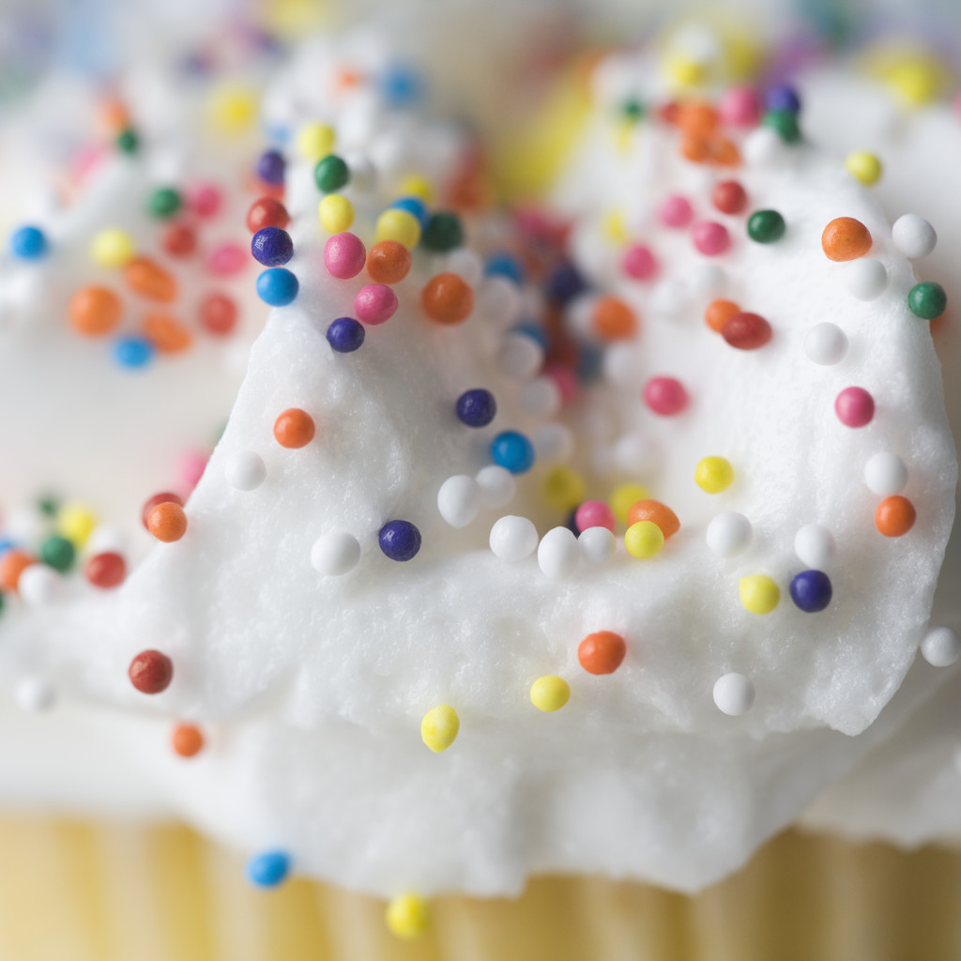  sprinkle | squ  square
st  stop | str  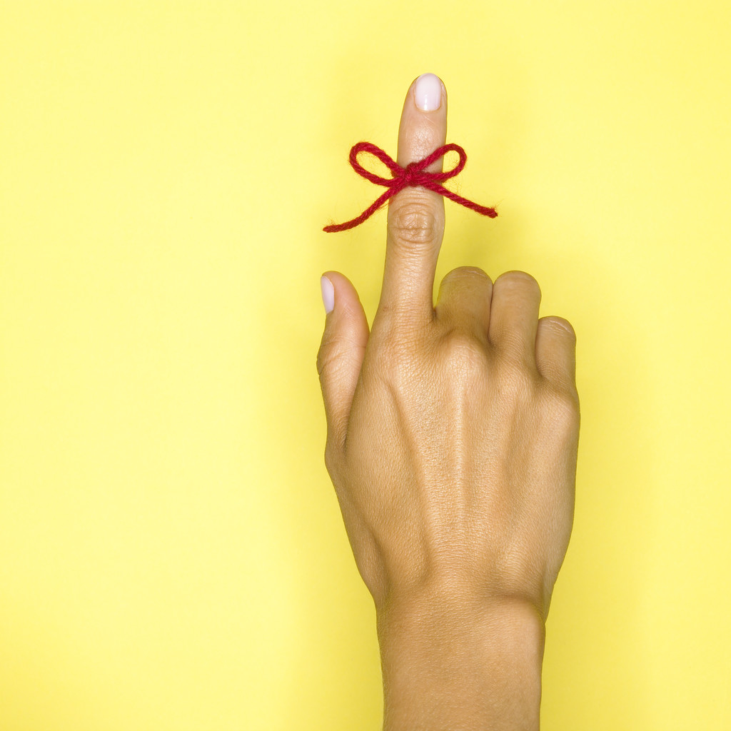  string | sw  swing | thr  3  three | tr  tree
Blends Chart

